ROTEADORES
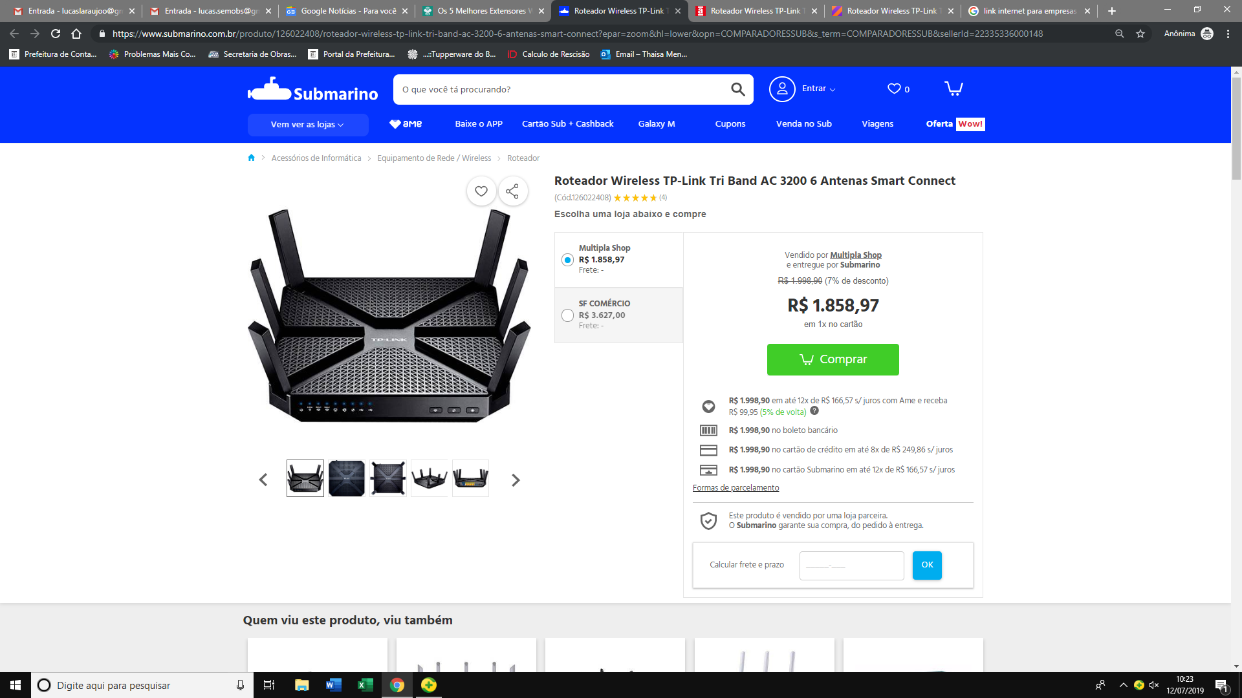
https://www.submarino.com.br/produto/126022408/roteador-wireless-tp-link-tri-band-ac-3200-6-antenas-smart-connect?epar=zoom&hl=lower&opn=COMPARADORESSUB&s_term=COMPARADORESSUB&sellerId=22335336000148

https://www.americanas.com.br/produto/126022408/roteador-wireless-tp-link-tri-band-ac-3200-6-antenas-smart-connect?epar=ZOOM&hl=lower&opn=YSMESP&s_term=YYNKZU&sellerId=22335336000148

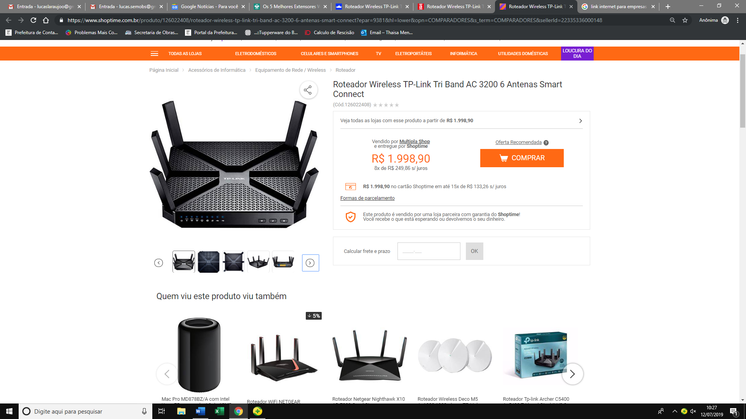
https://www.shoptime.com.br/produto/126022408/roteador-wireless-tp-link-tri-band-ac-3200-6-antenas-smart-connect?epar=9381&hl=lower&opn=COMPARADORES&s_term=COMPARADORES&sellerId=22335336000148

REPETIDORES
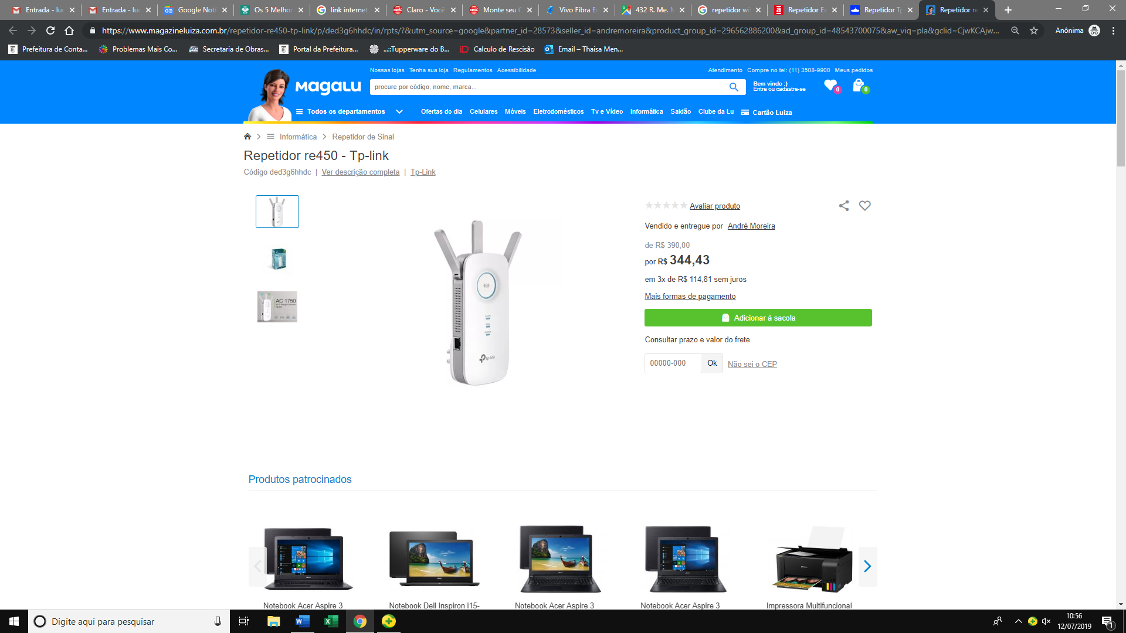
https://www.magazineluiza.com.br/repetidor-re450-tp-link/p/ded3g6hhdc/in/rpts/?&utm_source=google&partner_id=28573&seller_id=andremoreira&product_group_id=296562886200&ad_group_id=48543700075&aw_viq=pla&gclid=CjwKCAjw36DpBRAYEiwAmVVDMJAVzj_ST13jVuTiMntJNzK4__q4YTQJCoqH91pyj8PBBqevpCpU_BoCAaQQAvD_BwE

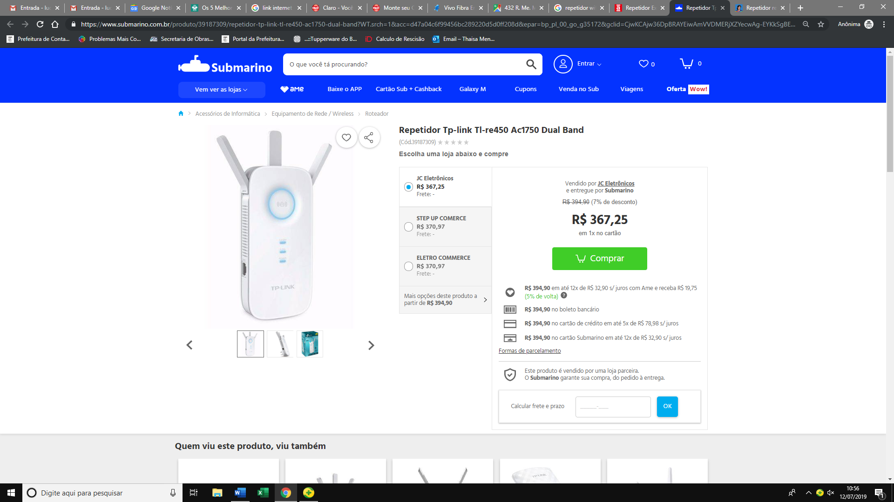
https://www.submarino.com.br/produto/39187309/repetidor-tp-link-tl-re450-ac1750-dual-band?WT.srch=1&acc=d47a04c6f99456bc289220d5d0ff208d&epar=bp_pl_00_go_g35172&gclid=CjwKCAjw36DpBRAYEiwAmVVDMERjXZYecwAg-EYKkSgBEd56OtxcaiI6eeEajxpzmO5UgukLW6w-bBoCw_IQAvD_BwE&i=5cf2080149f937f6257fb013&o=5b4ca6cfebb19ac62c808fe6&opn=XMLGOOGLE&sellerId=23445867000156

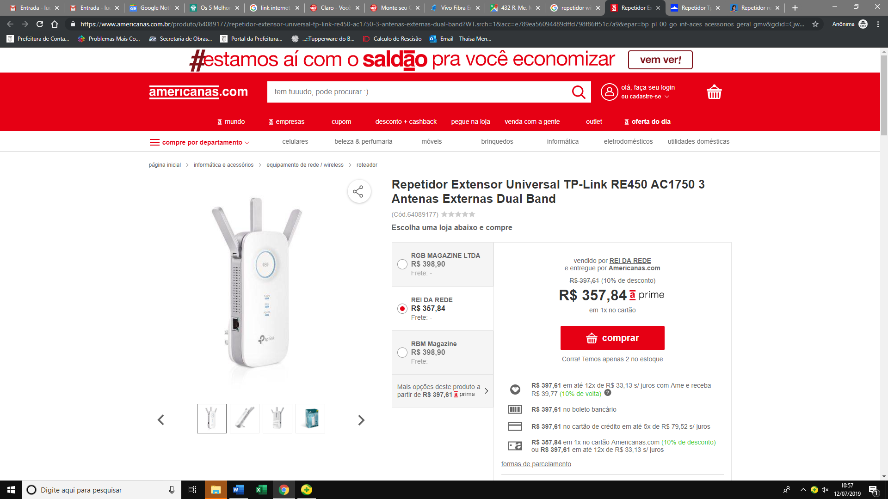
https://www.americanas.com.br/produto/64089177/repetidor-extensor-universal-tp-link-re450-ac1750-3-antenas-externas-dual-band?WT.srch=1&acc=e789ea56094489dffd798f86ff51c7a9&epar=bp_pl_00_go_inf-aces_acessorios_geral_gmv&gclid=CjwKCAjw36DpBRAYEiwAmVVDMD3E6I5gL4V8dWxlIDoEC9Ch9-T_xZcQOrgpD-Bnk-Bp_In-NeeR5BoC_ccQAvD_BwE&i=58f988eceec3dfb1f8a6f408&o=5cb0a1cb6c28a3cb50a38ff4&opn=YSMESP&sellerId=25529860000148

