Cabos
Cabo SATA
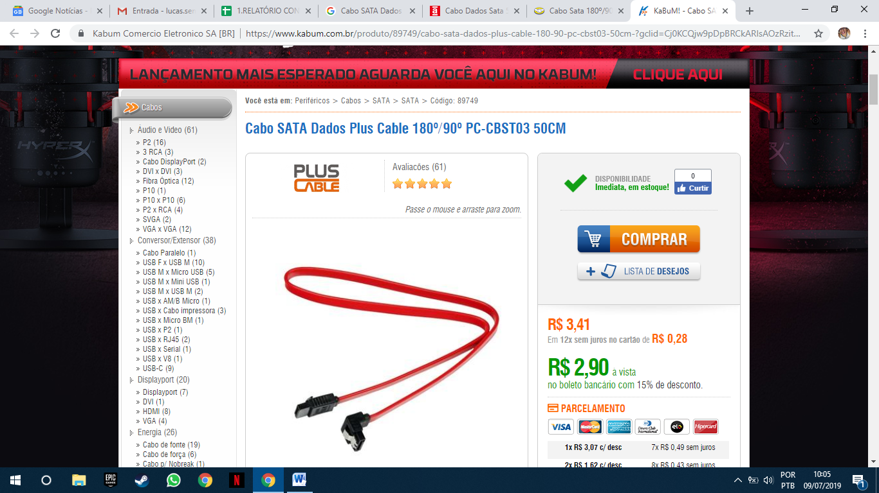
https://www.kabum.com.br/produto/89749/cabo-sata-dados-plus-cable-180-90-pc-cbst03-50cm-?gclid=Cj0KCQjw9pDpBRCkARIsAOzRzitdXZ02KEsql2q4OWzJLI_CHQII9msQczCdxkNNzChiMha91lI-OsMaAuu2EALw_wcB
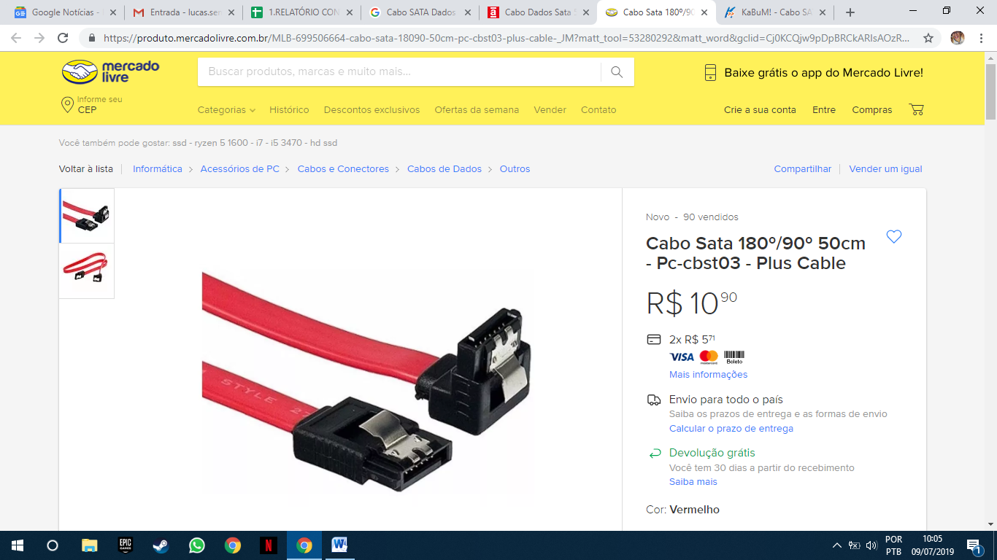
https://produto.mercadolivre.com.br/MLB-699506664-cabo-sata-18090-50cm-pc-cbst03-plus-cable-_JM?matt_tool=53280292&matt_word&gclid=Cj0KCQjw9pDpBRCkARIsAOzRzitY9coXCe13eVNBNLYh787QKviMzZYm9hD8pevP99B2qRfgsAlgMAkaAkECEALw_wcB&quantity=1&variation=32164049942
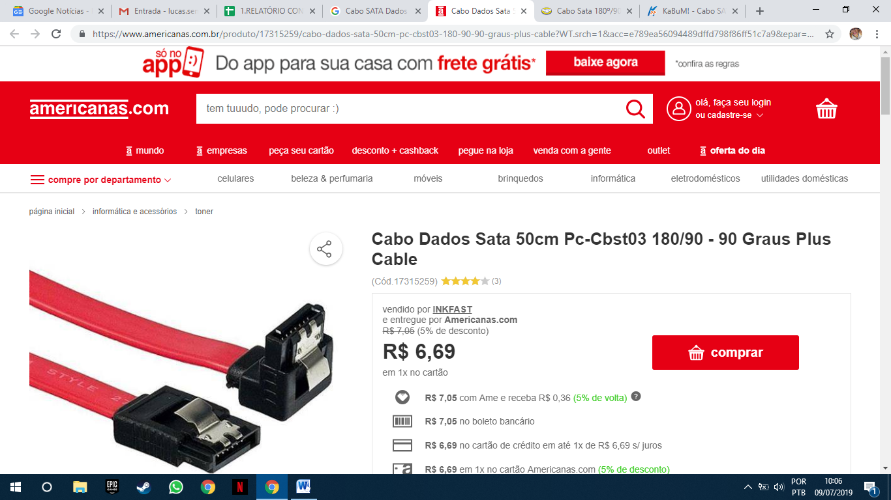
https://www.americanas.com.br/produto/17315259/cabo-dados-sata-50cm-pc-cbst03-180-90-90-graus-plus-cable?WT.srch=1&acc=e789ea56094489dffd798f86ff51c7a9&epar=bp_pl_00_go_inf-aces_acessorios_geral_gmv&gclid=Cj0KCQjw9pDpBRCkARIsAOzRzivQSMxlZx5gZpyfMhXnj_BQxVDClm2QkMZ-WLaxV0G7vCikG9TF6S0aApqeEALw_wcB&i=59cc70dfeec3dfb1f849de1f&o=57e42285eec3dfb1f8dddbe1&opn=YSMESP&sellerId=7684071000108
Cabo VGA
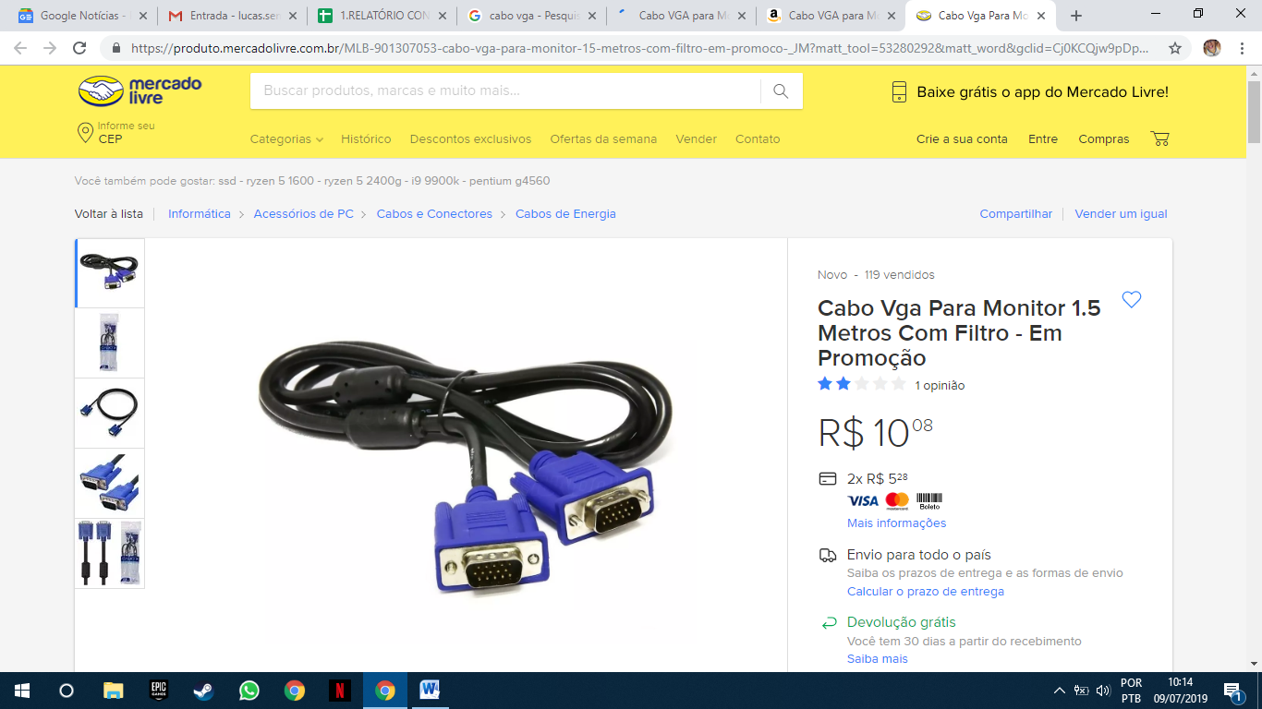
https://produto.mercadolivre.com.br/MLB-901307053-cabo-vga-para-monitor-15-metros-com-filtro-em-promoco-_JM?matt_tool=53280292&matt_word&gclid=Cj0KCQjw9pDpBRCkARIsAOzRziukboQLlWp3MLaHZLB4SrGUtOnTMT6yUk1cwJk4BN9p3LgocYPqhsgaAjAlEALw_wcB&quantity=1
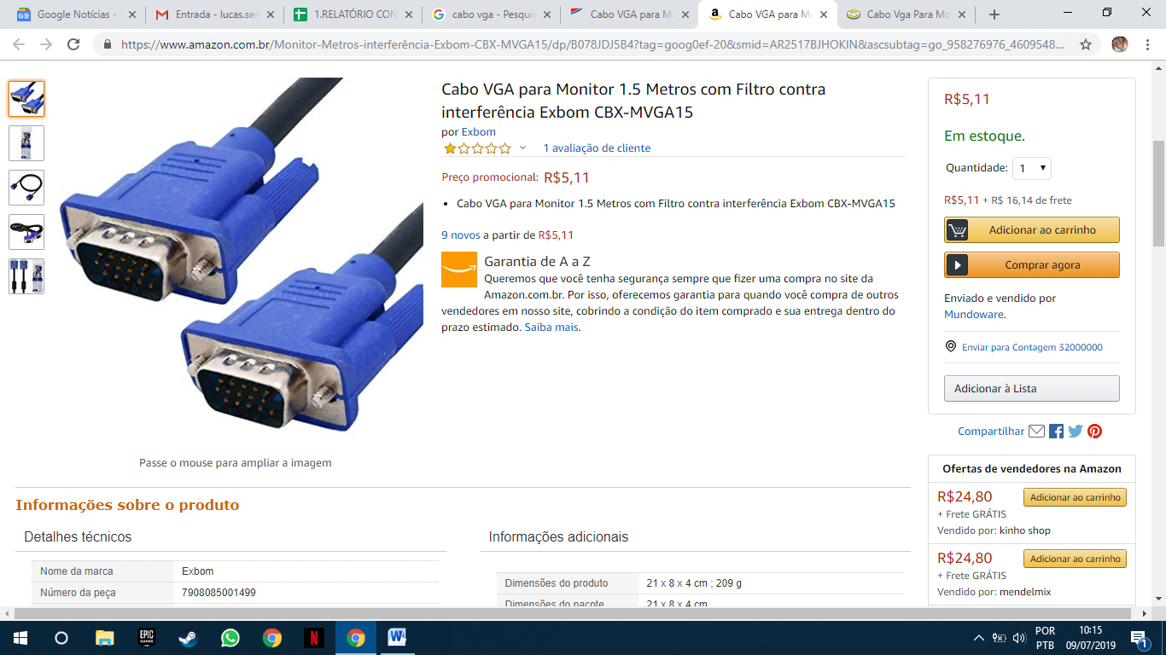
https://www.amazon.com.br/Monitor-Metros-interfer%C3%AAncia-Exbom-CBX-MVGA15/dp/B078JDJ5B4?tag=goog0ef-20&smid=AR2517BJHOKIN&ascsubtag=go_958276976_46095487085_227548540242_pla-644572534034_c_
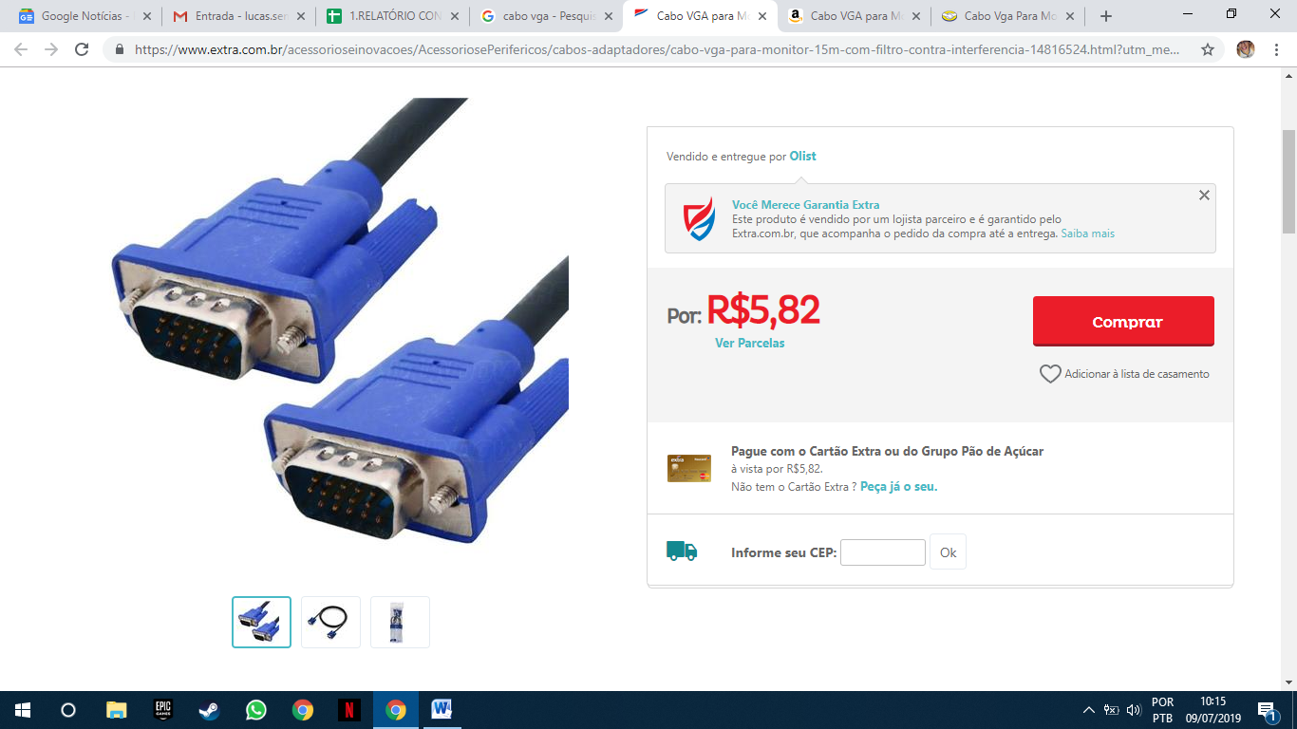
https://www.extra.com.br/acessorioseinovacoes/AcessoriosePerifericos/cabos-adaptadores/cabo-vga-para-monitor-15m-com-filtro-contra-interferencia-14816524.html?utm_medium=cpc&utm_source=gp_pla&IdSku=14816524&idLojista=12231&utm_campaign=info_shopping&gclid=Cj0KCQjw9pDpBRCkARIsAOzRziuS7MdbuVbxviZAWJse-va3d0Ez_jl7Cfzm_6xxV-7AALuZgJ2jaYwaAoLeEALw_wcB

Placas
Placa de rede WI-FI
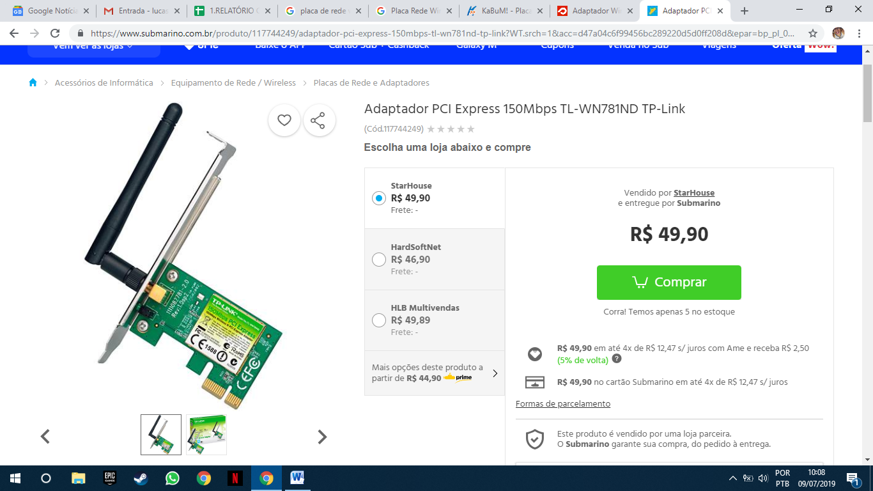
https://www.submarino.com.br/produto/117744249/adaptador-pci-express-150mbps-tl-wn781nd-tp-link?WT.srch=1&acc=d47a04c6f99456bc289220d5d0ff208d&epar=bp_pl_00_go_g35172&gclid=Cj0KCQjw9pDpBRCkARIsAOzRzitxkJVc4ZdCcDFPfgPvEbanqnJxFWy8inmCih-WfLM7K-kVBRykwoQaAr9QEALw_wcB&i=573fde3beec3dfb1f8009dba&o=55bf85ca9c3238c7d1adbc86&opn=XMLGOOGLE&sellerId=4617659000142

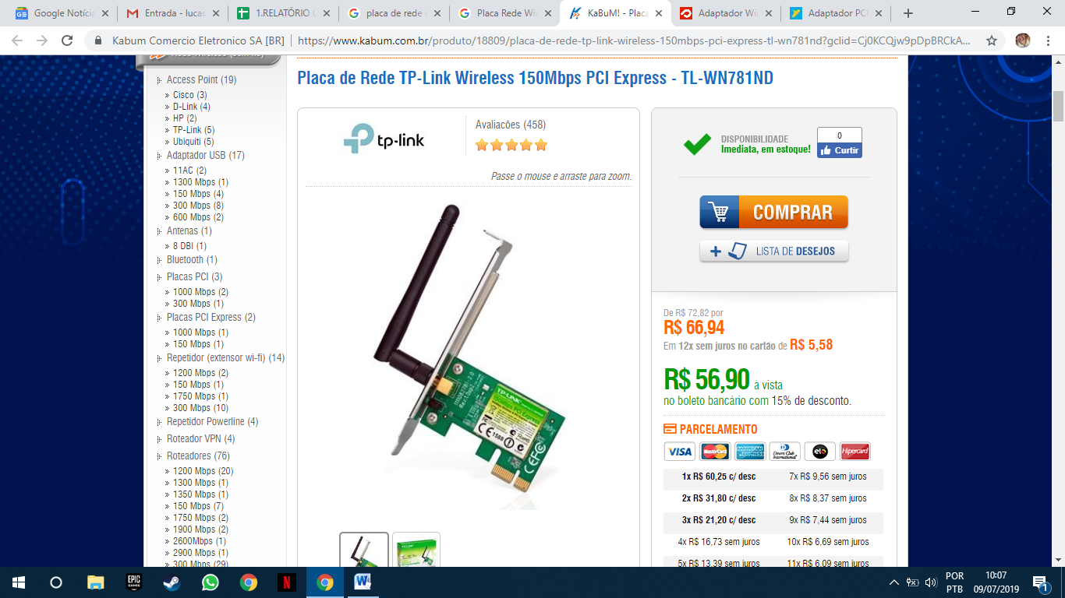
https://www.kabum.com.br/produto/18809/placa-de-rede-tp-link-wireless-150mbps-pci-express-tl-wn781nd?gclid=Cj0KCQjw9pDpBRCkARIsAOzRziumAZ0mV5a27gxvSFpzfZXKfQsKUYSUkGl8dZ4Ztpdscv7rJnk4V48aAtb5EALw_wcB
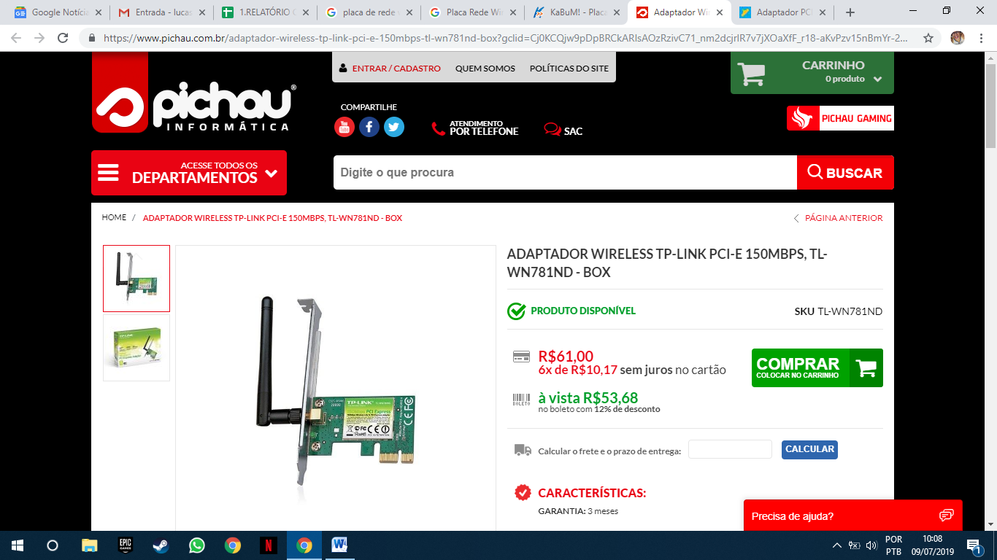
https://www.pichau.com.br/adaptador-wireless-tp-link-pci-e-150mbps-tl-wn781nd-box?gclid=Cj0KCQjw9pDpBRCkARIsAOzRzivC71_nm2dcjrlR7v7jXOaXfF_r18-aKvPzv15nBmYr-2FPfRvD6YwaAj57EALw_wcB
PLACA DE REDE OFFBOARD
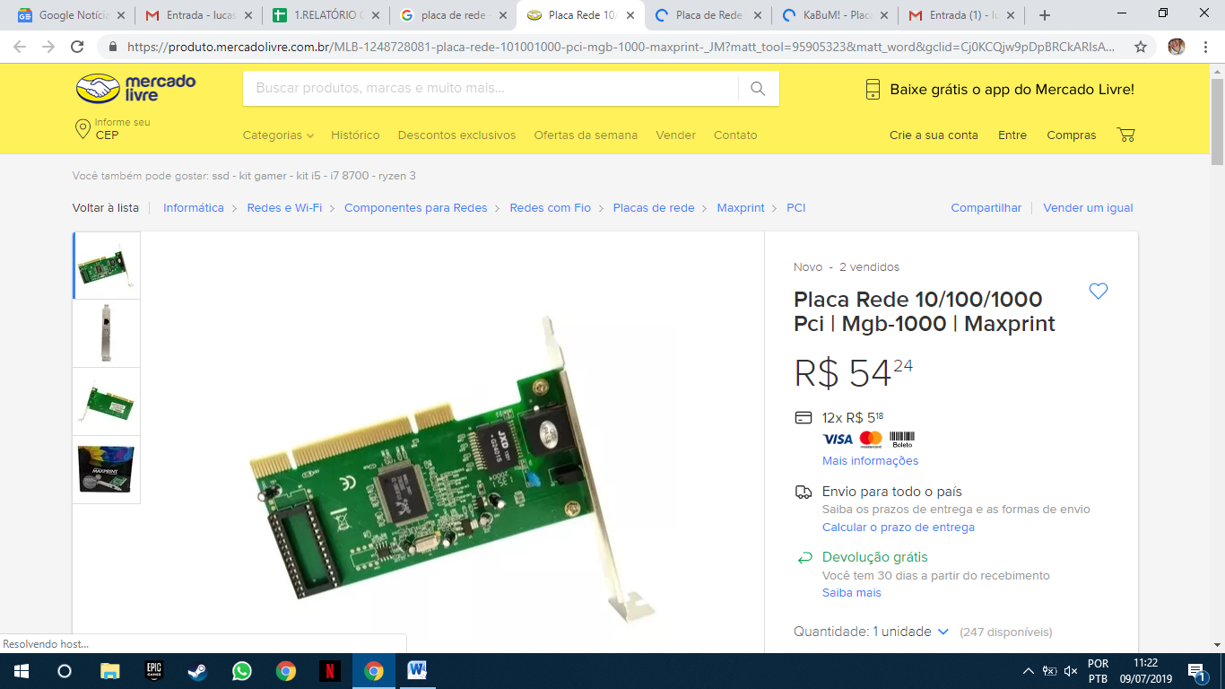
https://produto.mercadolivre.com.br/MLB-1248728081-placa-rede-101001000-pci-mgb-1000-maxprint-_JM?matt_tool=95905323&matt_word&gclid=Cj0KCQjw9pDpBRCkARIsAOzRzisI4ZfaovjYMV6nqOrmiQN4w2182JckRq464OmGtgQLSEYL-4gWQIIaAnLREALw_wcB&quantity=1
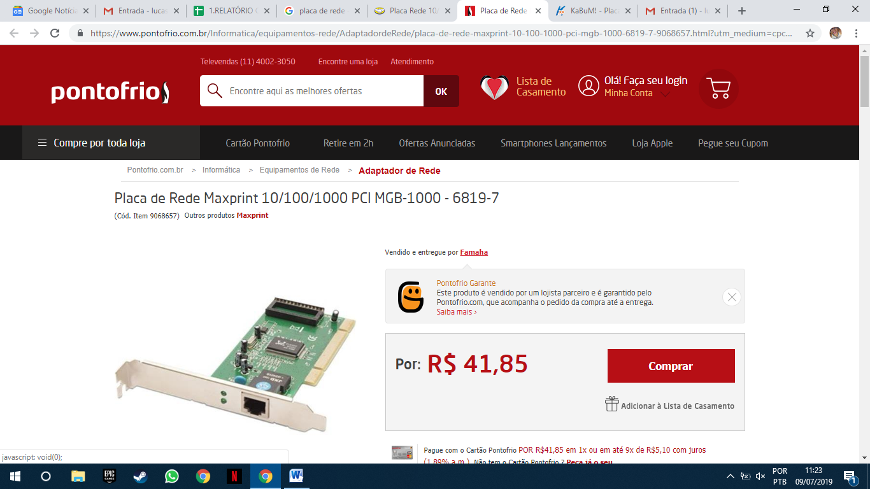
https://www.pontofrio.com.br/Informatica/equipamentos-rede/AdaptadordeRede/placa-de-rede-maxprint-10-100-1000-pci-mgb-1000-6819-7-9068657.html?utm_medium=cpc&utm_source=gp_pla&IdSku=9068657&idLojista=16477&utm_campaign=info_shopping&gclid=Cj0KCQjw9pDpBRCkARIsAOzRzitnfFCDcaM7dpbBtR4HCF3b4b4fJIGD9HmdqMZDUeeSxNkyYmeQvG0aAl4DEALw_wcB
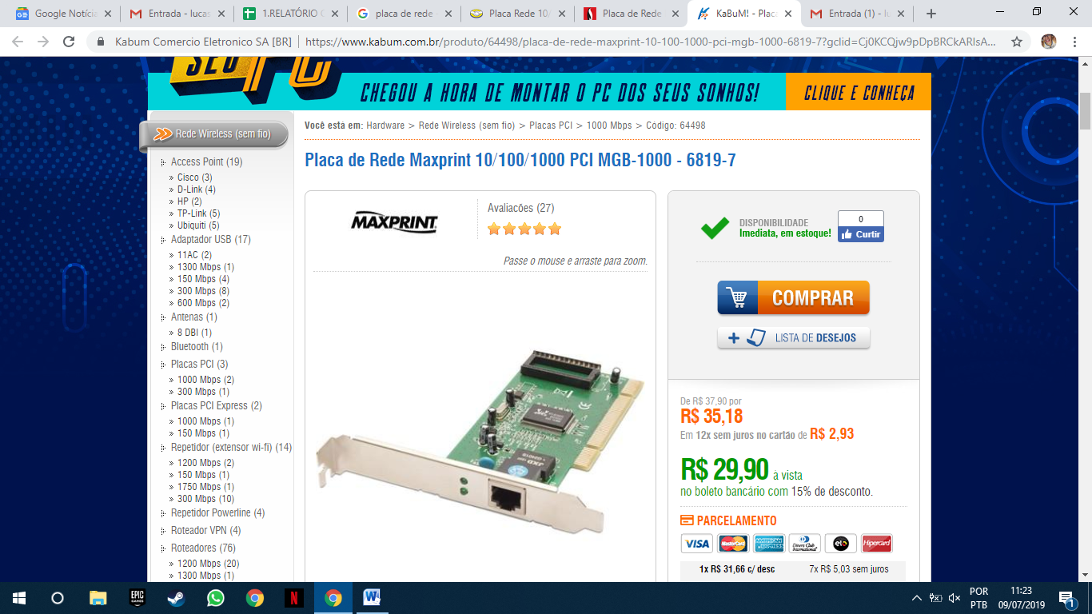
https://www.kabum.com.br/produto/64498/placa-de-rede-maxprint-10-100-1000-pci-mgb-1000-6819-7?gclid=Cj0KCQjw9pDpBRCkARIsAOzRziunVBK9wS-hMEukKaXgthAGFyrut_deHPtsZZH_D9JXdCkRGuiXBiwaAjjqEALw_wcB

Placa de Vídeo(Básica)
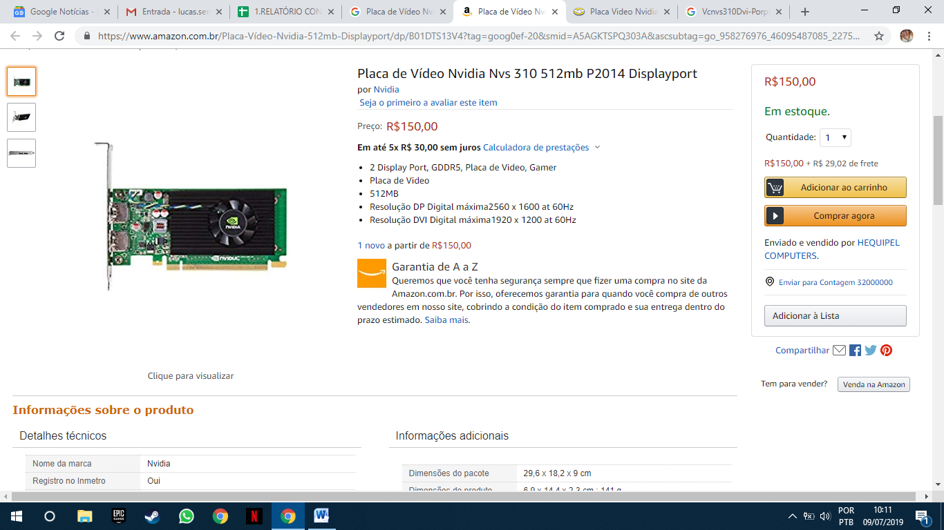
https://www.amazon.com.br/Placa-V%C3%ADdeo-Nvidia-512mb-Displayport/dp/B01DTS13V4?tag=goog0ef-20&smid=A5AGKTSPQ303A&ascsubtag=go_958276976_46095487085_227548540242_pla-780381397590_c_
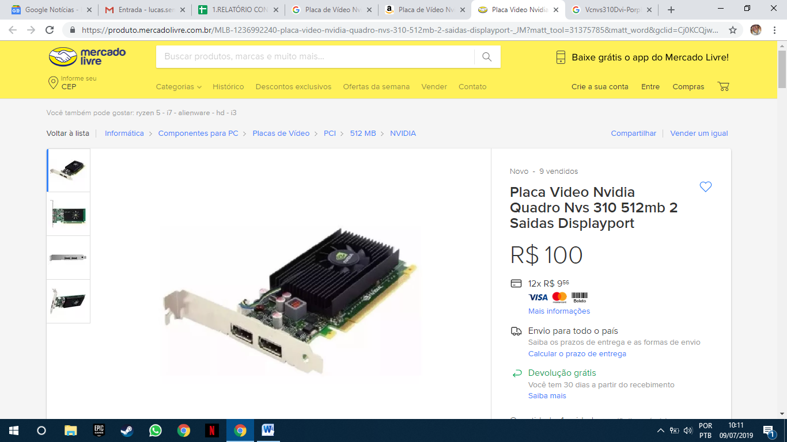
https://produto.mercadolivre.com.br/MLB-1236992240-placa-video-nvidia-quadro-nvs-310-512mb-2-saidas-displayport-_JM?matt_tool=31375785&matt_word&gclid=Cj0KCQjw9pDpBRCkARIsAOzRzivpyySPzlZ6KHmK80pp4CBa2JVqWay01IF-eJWL4Hwyvd6rcj4QajcaAgFSEALw_wcB&quantity=1
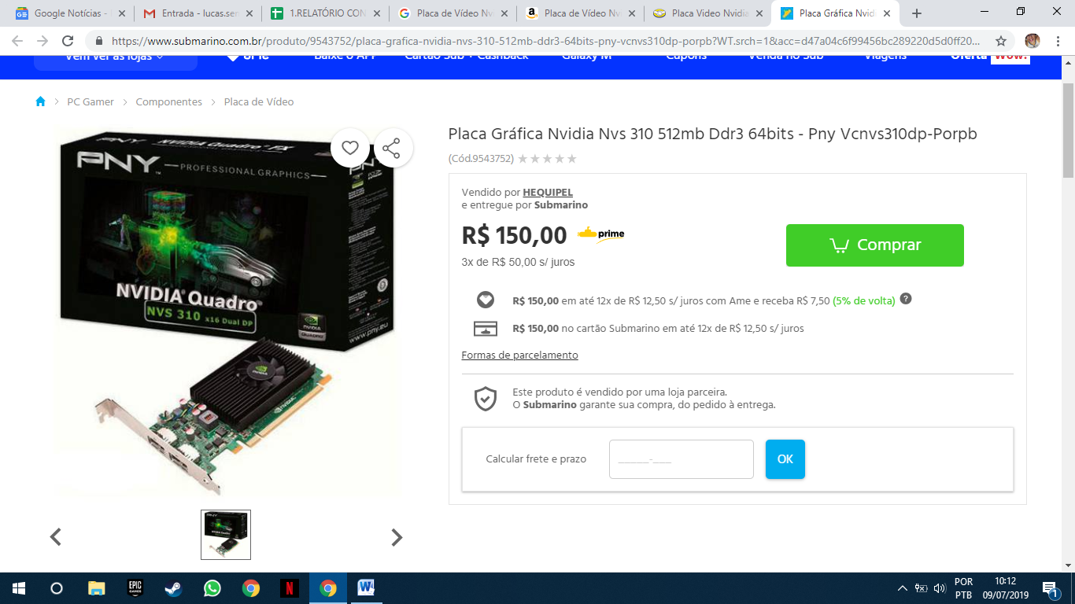
https://www.submarino.com.br/produto/9543752/placa-grafica-nvidia-nvs-310-512mb-ddr3-64bits-pny-vcnvs310dp-porpb?WT.srch=1&acc=d47a04c6f99456bc289220d5d0ff208d&epar=bp_pl_00_go_pla_pcgamer_geral_gmv&gclid=Cj0KCQjw9pDpBRCkARIsAOzRzisl4e9Q_HguGMOg4bBVR2TkI4d_OhKVNkwPJ57GH7fMAkjEJeh6h9EaAgZHEALw_wcB&i=5b73b46eeec3dfb1f8bc7a40&o=5957f528eec3dfb1f85b2358&opn=XMLGOOGLE&sellerId=7658434000122

MEMORIA RAM
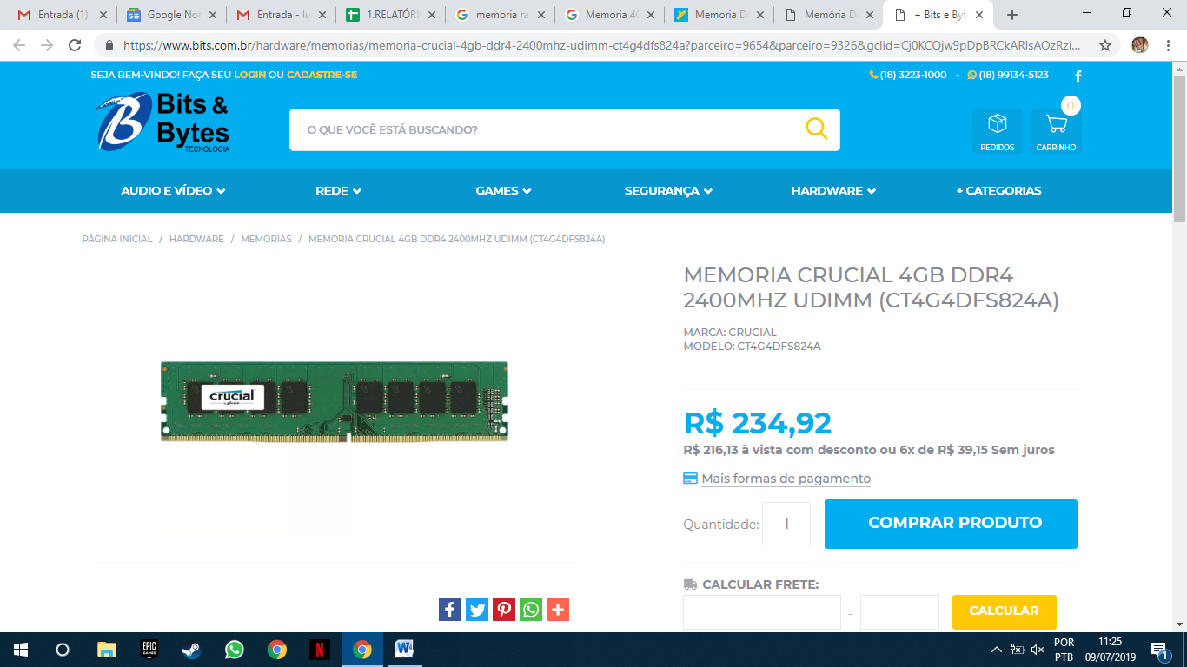
https://www.bits.com.br/hardware/memorias/memoria-crucial-4gb-ddr4-2400mhz-udimm-ct4g4dfs824a?parceiro=9654&parceiro=9326&gclid=Cj0KCQjw9pDpBRCkARIsAOzRzivZYC1op5NTGNoj6C8jnPc4bnua3s0dZl4U5qGC2GdyBkMui_XnVa8aAjgIEALw_wcB
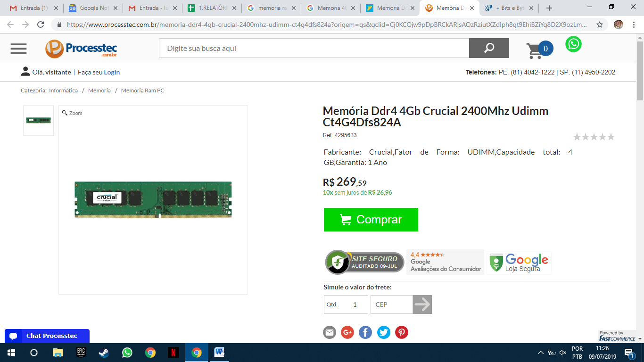
https://www.processtec.com.br/memoria-ddr4-4gb-crucial-2400mhz-udimm-ct4g4dfs824a?origem=gs&gclid=Cj0KCQjw9pDpBRCkARIsAOzRziutXZdIph8gt9EhiBZiYg8D2X9ozLmYQNnetIV9ZJ3p4i uuPNjK4Z8aAm9TEALw_wcB
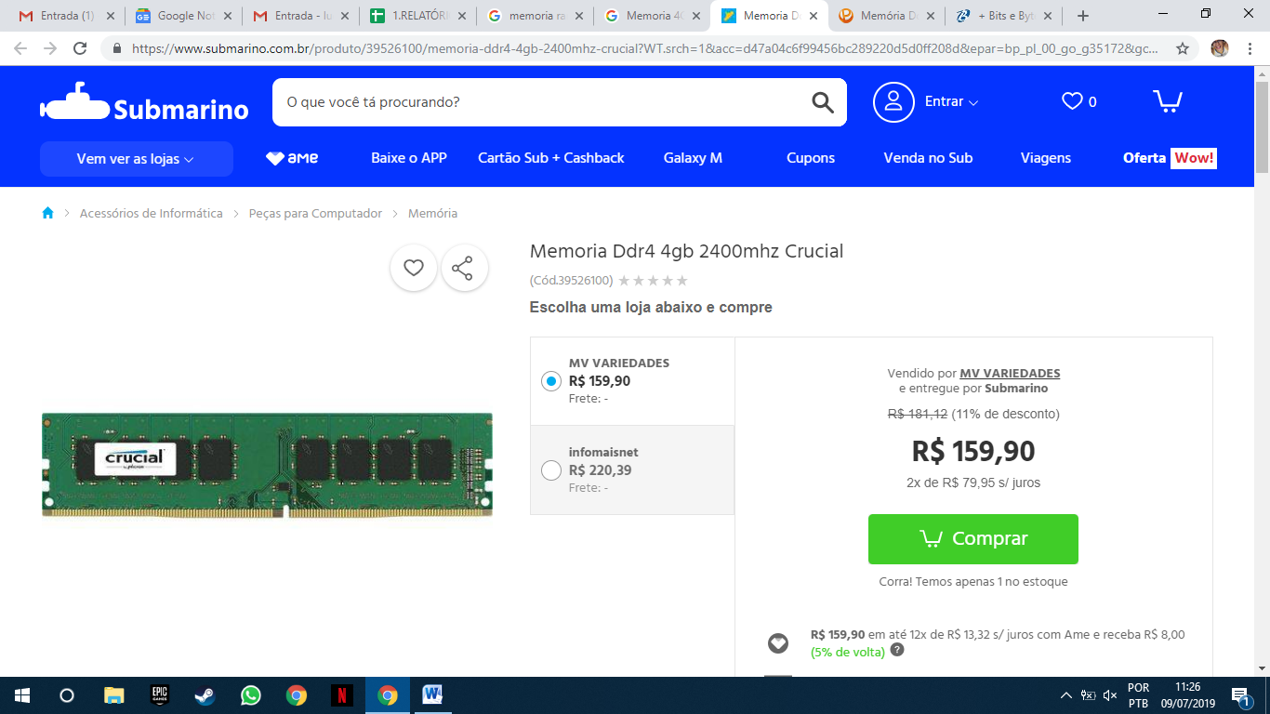
https://www.submarino.com.br/produto/39526100/memoria-ddr4-4gb-2400mhz-crucial?WT.srch=1&acc=d47a04c6f99456bc289220d5d0ff208d&epar=bp_pl_00_go_g35172&gclid=Cj0KCQjw9pDpBRCkARIsAOzRzivAx7cThTCc-Uv27QQzO60Uviwtg9vgU4aVEUFMsPSR2jGoFLcXyyAaAvDvEALw_wcB&i=598011feeec3dfb1f8ef8b19&o=5b5739ecebb19ac62c8a2271&opn=XMLGOOGLE&sellerId=8039382000179

Disco rígido (HD)
HD SATA
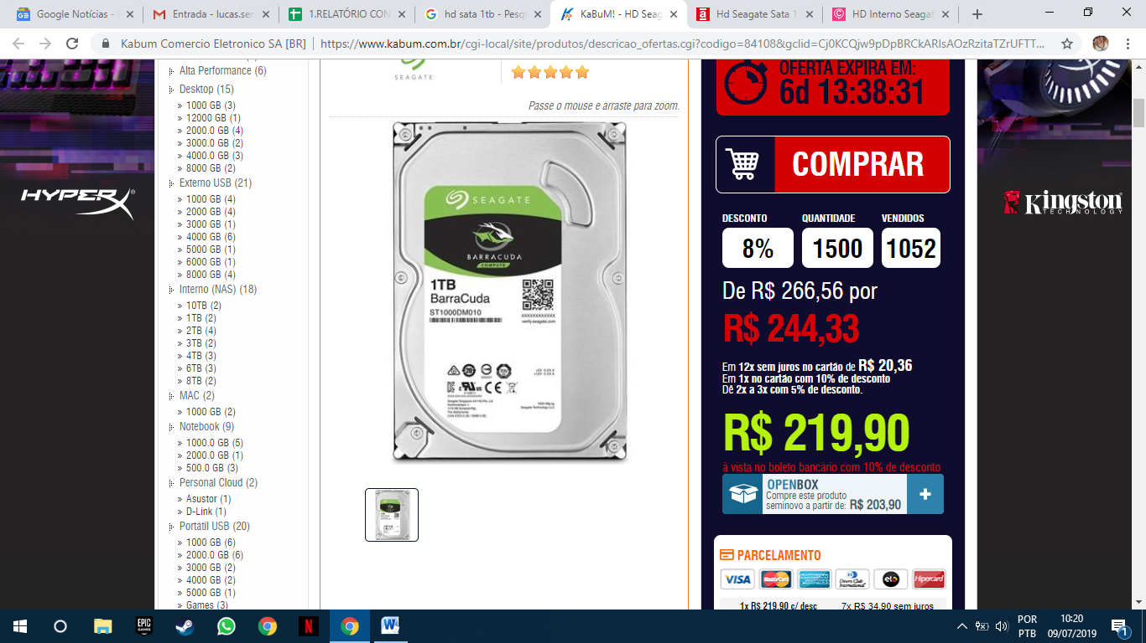
https://www.kabum.com.br/cgi-local/site/produtos/descricao_ofertas.cgi?codigo=84108&gclid=Cj0KCQjw9pDpBRCkARIsAOzRzitaTZrUFTTTQfb34Mes-ZOVLdmkCNZoXqf3fEelOReGyKJ6rLXopvQaAkxwEALw_wcB
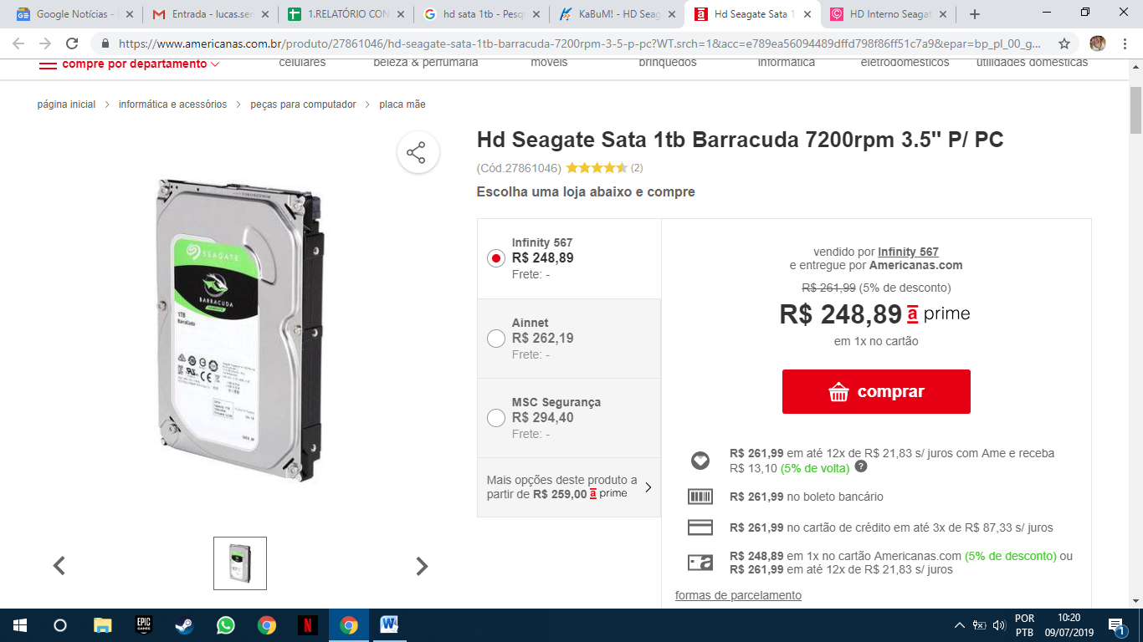
https://www.americanas.com.br/produto/27861046/hd-seagate-sata-1tb-barracuda-7200rpm-3-5-p-pc?WT.srch=1&acc=e789ea56094489dffd798f86ff51c7a9&epar=bp_pl_00_go_inf-aces_acessorios_geral_gmv&gclid=Cj0KCQjw9pDpBRCkARIsAOzRzisf18urg31nfJ98a3FQcN7IhgVMQ0SKzeMGO_BMvxI0D4n4J3yOU-gaAmUFEALw_wcB&i=5c58fe2d49f937f6258bc565&o=59e4e43deec3dfb1f866cfda&opn=YSMESP&sellerId=17717228000108
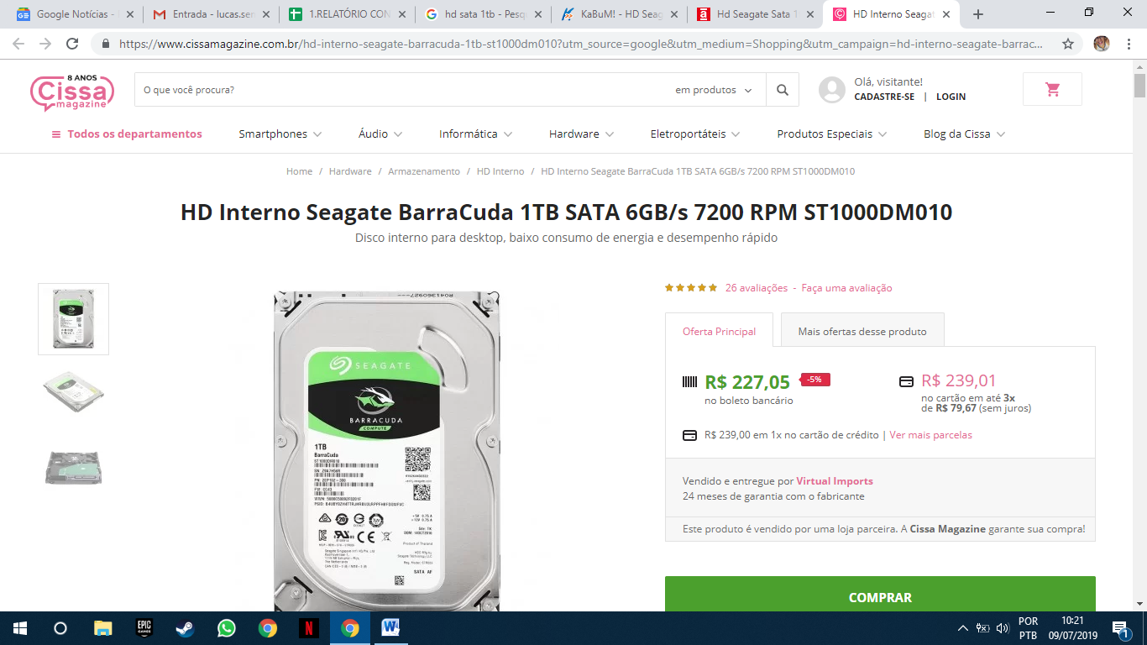
https://www.cissamagazine.com.br/hd-interno-seagate-barracuda-1tb-st1000dm010?utm_source=google&utm_medium=Shopping&utm_campaign=hd-interno-seagate-barracuda-1tb-st1000dm010&inStock&gclid=Cj0KCQjw9pDpBRCkARIsAOzRziuATmFEAkp2__vZ-xfv03XE9qywzyT7m_Epu8nb2BOn1WDKHOg5XlcaAvPJEALw_wcB
Fonte
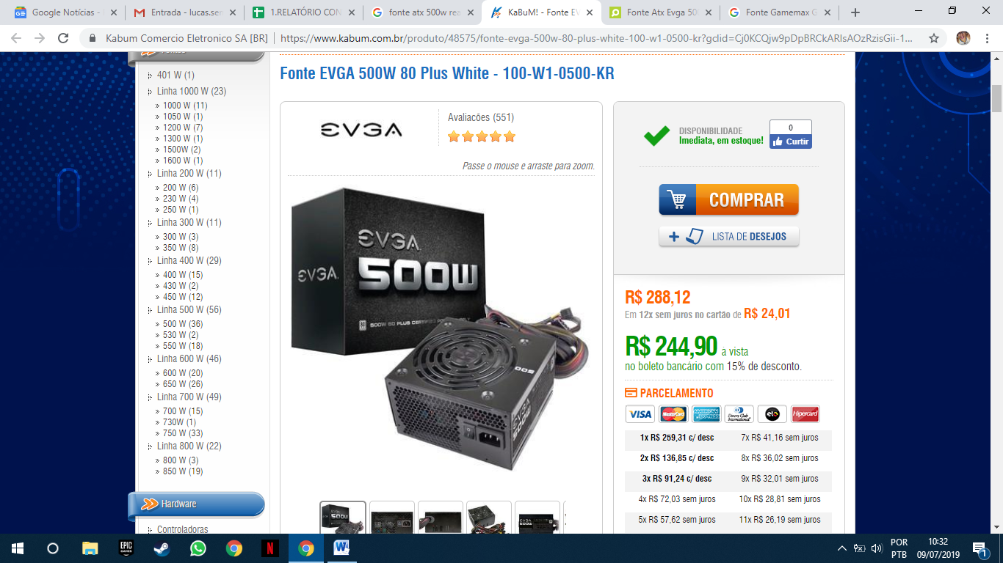
https://www.kabum.com.br/produto/48575/fonte-evga-500w-80-plus-white-100-w1-0500-kr?gclid=Cj0KCQjw9pDpBRCkARIsAOzRzisGii-12Byn4BU8JgcGxy7V9uCxYTidBLVZLvx0FcjEhddn344Dx9YaAovlEALw_wcB
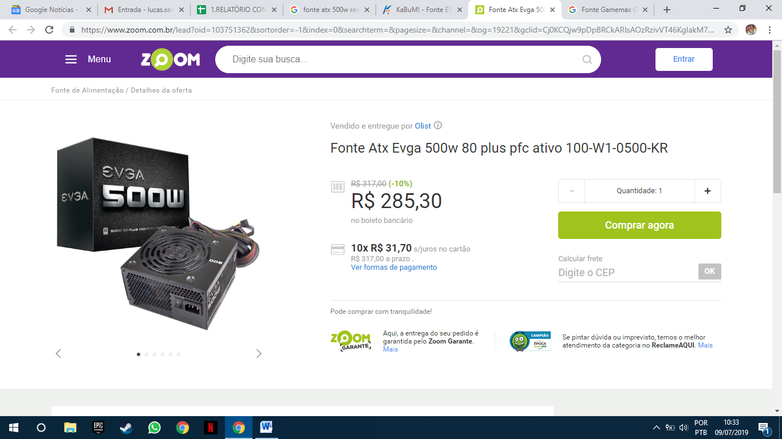
https://www.zoom.com.br/lead?oid=103751362&sortorder=-1&index=0&searchterm=&pagesize=&channel=&og=19221&gclid=Cj0KCQjw9pDpBRCkARIsAOzRzivVT46KgIakM7BgCropd-BcUsHiLEI-IE3dOYQFeDZiK3o7t0WrZqAaAlcDEALw_wcB
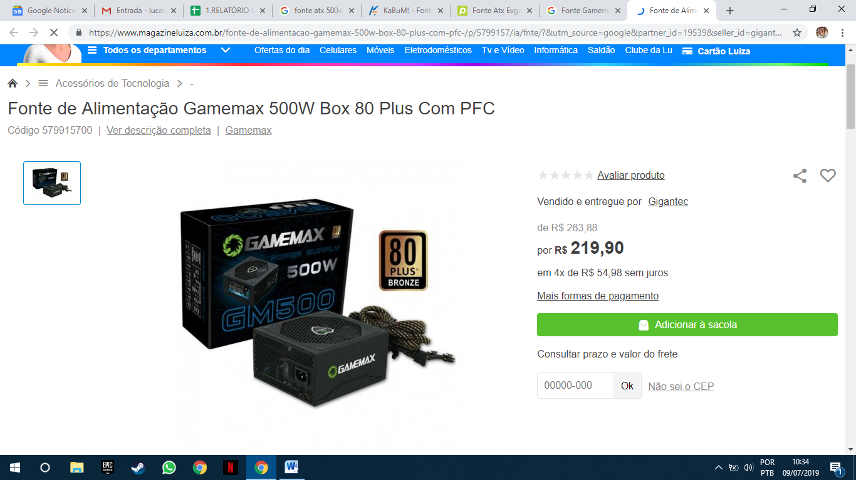
https://www.magazineluiza.com.br/fonte-de-alimentacao-gamemax-500w-box-80-plus-com-pfc-/p/5799157/ia/fnte/?&utm_source=google&partner_id=19539&seller_id=gigantec&product_group_id=347842847493&ad_group_id=52254738913&aw_viq=pla&gclid=Cj0KCQjw9pDpBRCkARIsAOzRzis4K7ghJLDrKmvyEUqSWxNVJGcod1A0p4obn7dgd7C26MIBf829zI4aAkHpEALw_wcB

