ORÇAMENTO
21/05/2019

NOTEBOOK

PROCESSADOR: INTEL CORE i5 ou AMD RAYZEN (Versões e Gerações atualizadas)
MEMÓRIA: 8GB DDR4
PLACA DE VIDEO: 4GB DDR4
DISCO RÍGIDO: HDD DE 1 TB (7200 RPM)
MONITOR: LED 15.6
ACESSÓRIO: MOUSE
SISTEMA OPERACIONAL: WINDOWS 64BITS (VERSÕES RECENTES), MICROSOFT OFFICE, ANTIVÍRUS.
CONEXÕES: USB 3.0, USB 2.0, HDMI.

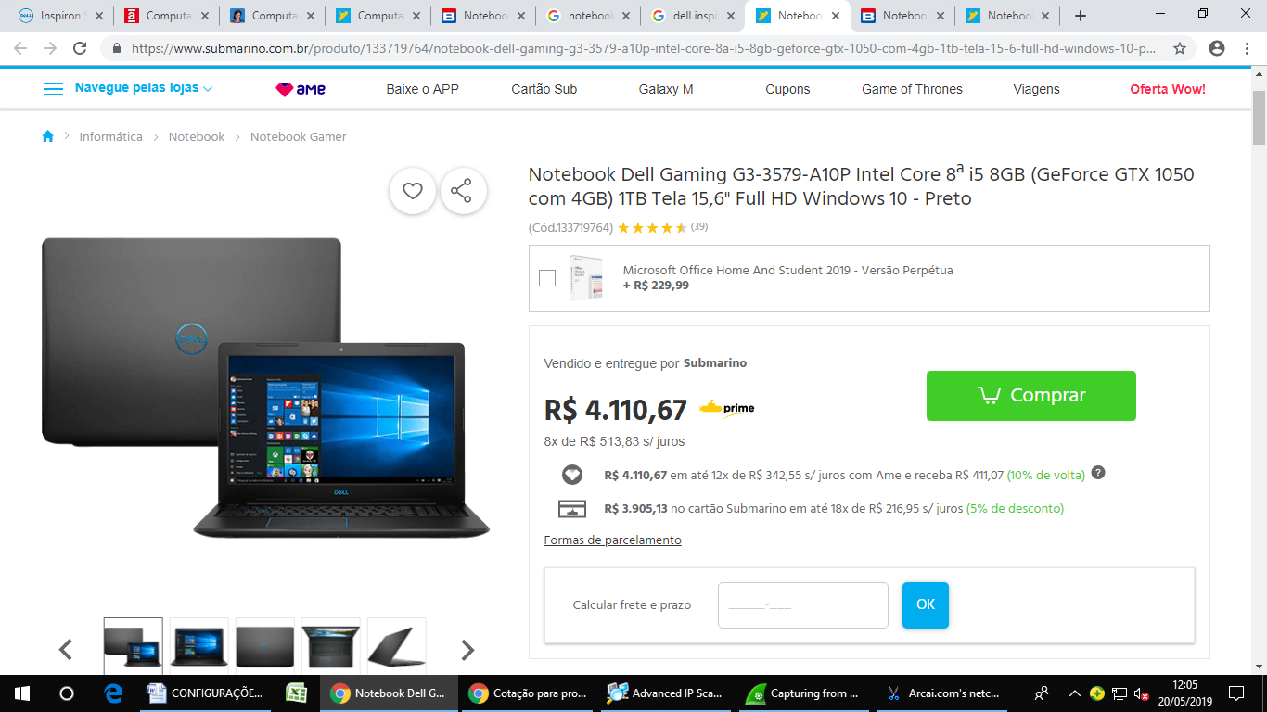
https://www.submarino.com.br/produto/133719764/notebook-dell-gaming-g3-3579-a10p-intel-core-8a-i5-8gb-geforce-gtx-1050-com-4gb-1tb-tela-15-6-full-hd-windows-10-preto?WT.srch=1&acc=d47a04c6f99456bc289220d5d0ff208d&epar=bp_pl_00_go_g35174&gclid=EAIaIQobChMIu-LP0bCq4gIVj4aRCh1JdQLZEAQYFSABEgLZb_D_BwE&i=561e53416ed24cafb5322074&o=5b3dc864ebb19ac62c7ab376&opn=XMLGOOGLE&sellerId=00776574000660
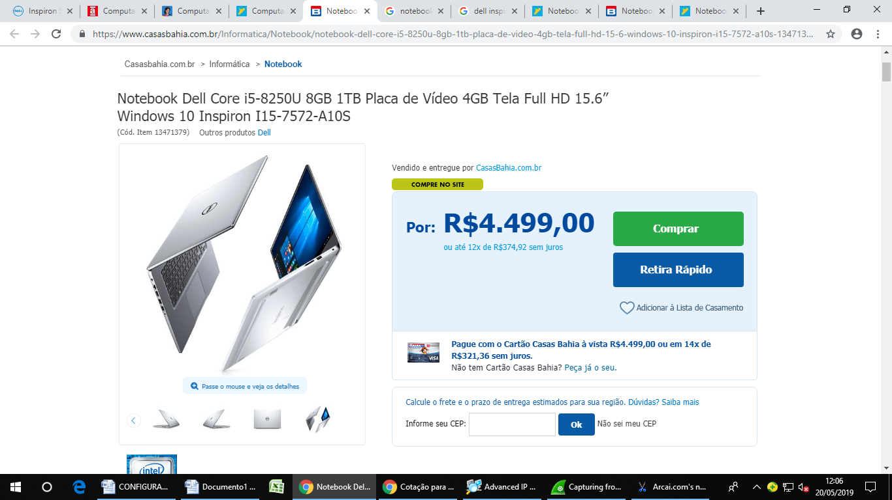
https://www.casasbahia.com.br/Informatica/Notebook/notebook-dell-core-i5-8250u-8gb-1tb-placa-de-video-4gb-tela-full-hd-15-6-windows-10-inspiron-i15-7572-a10s-13471379.html?utm_medium=Cpc&utm_source=GP_PLA&IdSku=13471379&idLojista=10037&utm_campaign=info_notebooks_shopping&gclid=EAIaIQobChMI2Jum8K6q4gIVkIeRCh1DyAHrEAQYBCABEgIkIvD_BwE
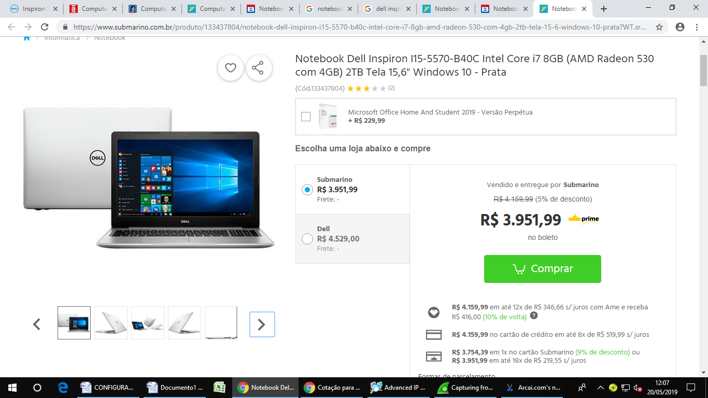
https://www.submarino.com.br/produto/133437804/notebook-dell-inspiron-i15-5570-b40c-intel-core-i7-8gb-amd-radeon-530-com-4gb-2tb-tela-15-6-windows-10-prata?WT.srch=1&acc=d47a04c6f99456bc289220d5d0ff208d&epar=bp_pl_00_go_g35174&gclid=EAIaIQobChMIu-LP0bCq4gIVj4aRCh1JdQLZEAQYHSABEgKrXfD_BwE&i=561e53416ed24cafb5322074&o=5b4cadcdebb19ac62c809511&opn=XMLGOOGLE&sellerId=00776574000660

