DESKTOP

PROCESSADOR: INTEL CORE i7 ou AMD RAYZEN (Versões e Gerações atualizadas).
MEMÓRIA: 16GB DDR4.
DISCO RÍGIDO: HDD DE 1 TB (7200 RPM).

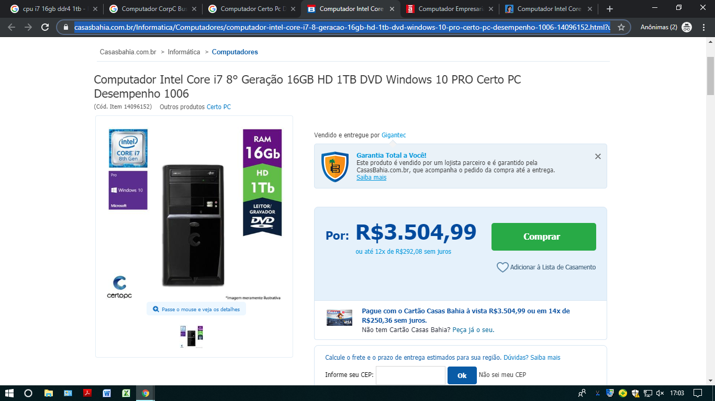
https://www.casasbahia.com.br/Informatica/Computadores/computador-intel-core-i7-8-geracao-16gb-hd-1tb-dvd-windows-10-pro-certo-pc-desempenho-1006-14096152.html?utm_medium=Cpc&utm_source=GP_PLA&IdSku=14096152&idLojista=10169&utm_campaign=info_shopping&gclid=Cj0KCQjwuLPnBRDjARIsACDzGL2Dds0s-MphUvH8Zgx0_8FOAeUj0aFXVldAzcoiEKLjxk104er0_BcaApxsEALw_wcB
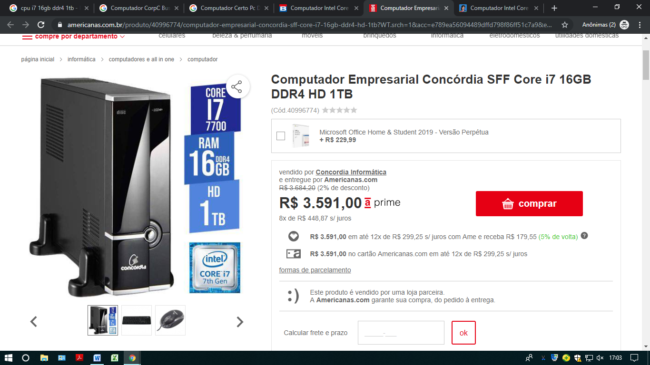
https://www.americanas.com.br/produto/40996774/computador-empresarial-concordia-sff-core-i7-16gb-ddr4-hd-1tb?WT.srch=1&acc=e789ea56094489dffd798f86ff51c7a9&epar=bp_pl_00_go_inf_notebooks_todas_geral_gmv&gclid=Cj0KCQjwuLPnBRDjARIsACDzGL2E9NBY3_jpo4MIxbfEIfLmUDIlJDdytyRnS-IMvtIqcmzXWjOXAwUaAvMBEALw_wcB&i=577ee392eec3dfb1f84b052a&o=5b71765cebb19ac62c9aeffe&opn=YSMESP&sellerId=5055328000129
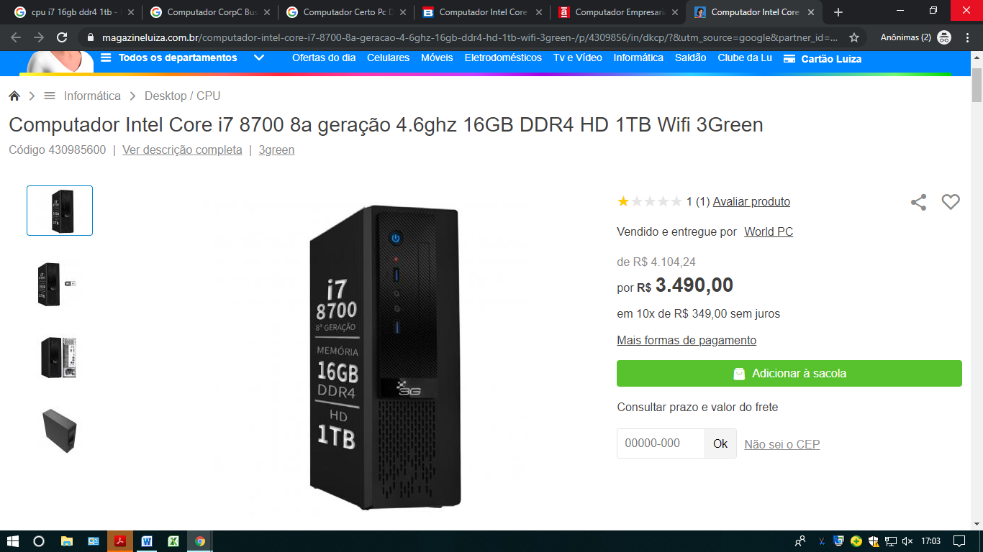
https://www.magazineluiza.com.br/computador-intel-core-i7-8700-8a-geracao-4-6ghz-16gb-ddr4-hd-1tb-wifi-3green-/p/4309856/in/dkcp/?&utm_source=google&partner_id=22085&seller_id=3greentechnology&product_group_id=296562886200&ad_group_id=48543700075&aw_viq=pla&gclid=Cj0KCQjwuLPnBRDjARIsACDzGL3dnWgC9hzaV4ZrxoZmI2CxhhhqTSjED86armQVjbSUW1YRz4tXTHcaAltAEALw_wcB

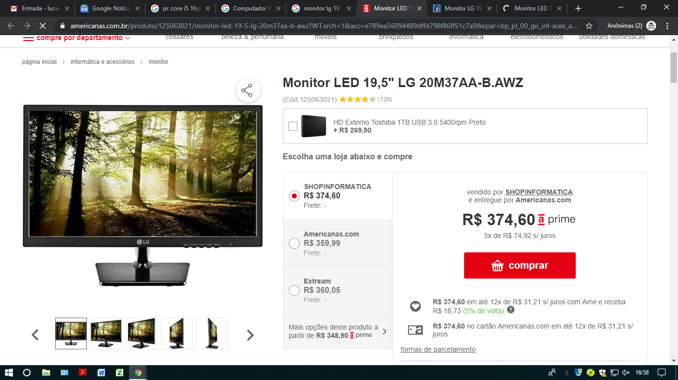
https://www.americanas.com.br/produto/125063021/monitor-led-19-5-lg-20m37aa-b-awz?WT.srch=1&acc=e789ea56094489dffd798f86ff51c7a9&epar=bp_pl_00_go_inf-aces_acessorios_geral_gmv&epar=bp_pl_00_go_inf-aces_acessorios_geral_gmv&gclid=Cj0KCQjwuLPnBRDjARIsACDzGL3Nk3y8J0OSVV5qcRLQZVWXz6QG8y2RYXqJKg2p_ya27bSZRNJBhusaAvNpEALw_wcB&i=5a5c2231eec3dfb1f81c4fee&o=56e1baf4eec3dfb1f8b224ae&opn=YSMESP&sellerId=29048892000182
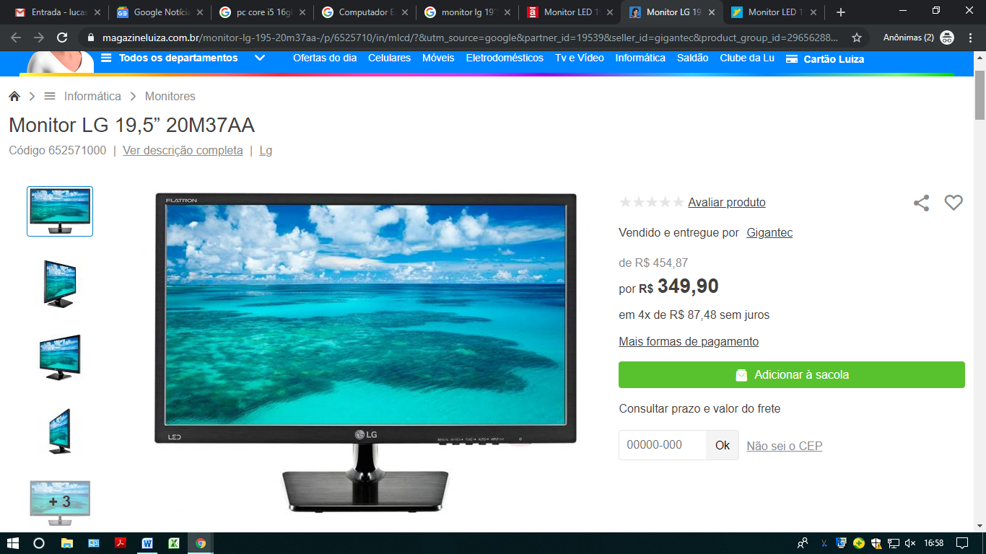
https://www.magazineluiza.com.br/monitor-lg-195-20m37aa-/p/6525710/in/mlcd/?&utm_source=google&partner_id=19539&seller_id=gigantec&product_group_id=296562886200&ad_group_id=48543700075&aw_viq=pla&gclid=Cj0KCQjwuLPnBRDjARIsACDzGL16pItPXNXfe0iCUE5fxgCv2gTnTvhniY8ChKjC6FkYUi4PH0VlPGkaAsOkEALw_wcB
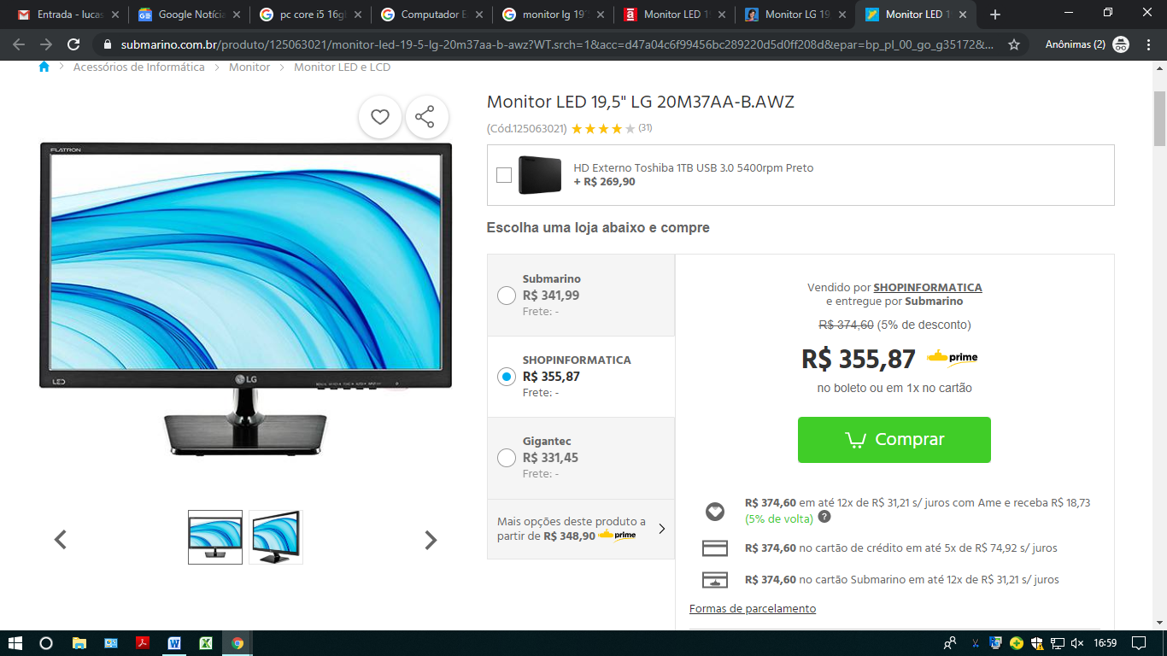
https://www.submarino.com.br/produto/125063021/monitor-led-19-5-lg-20m37aa-b-awz?WT.srch=1&acc=d47a04c6f99456bc289220d5d0ff208d&epar=bp_pl_00_go_g35172&gclid=Cj0KCQjwuLPnBRDjARIsACDzGL0-yfNNXntg-N3cV0U1CrgPEIiwwytDQ2ThsQi-aiiDiVP4ggjCwmUaAjRdEALw_wcB&i=5a5c3e38eec3dfb1f81fbfc8&o=56607f8126a311ff8bbf62ab&opn=XMLGOOGLE&sellerId=29048892000182

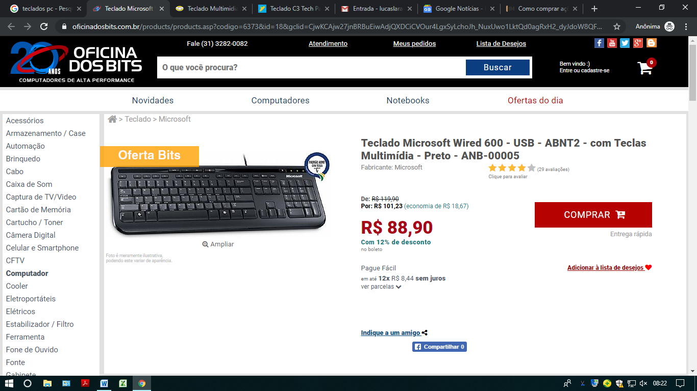
https://www.oficinadosbits.com.br/products/products.asp?codigo=6373&id=18&gclid=CjwKCAjw27jnBRBuEiwAdjQXDCiCVOur4LgxSyLchoJh_NuxUwo1LktQd0agRxH2_dyJdoW8QFkQWhoCjy8QAvD_BwE
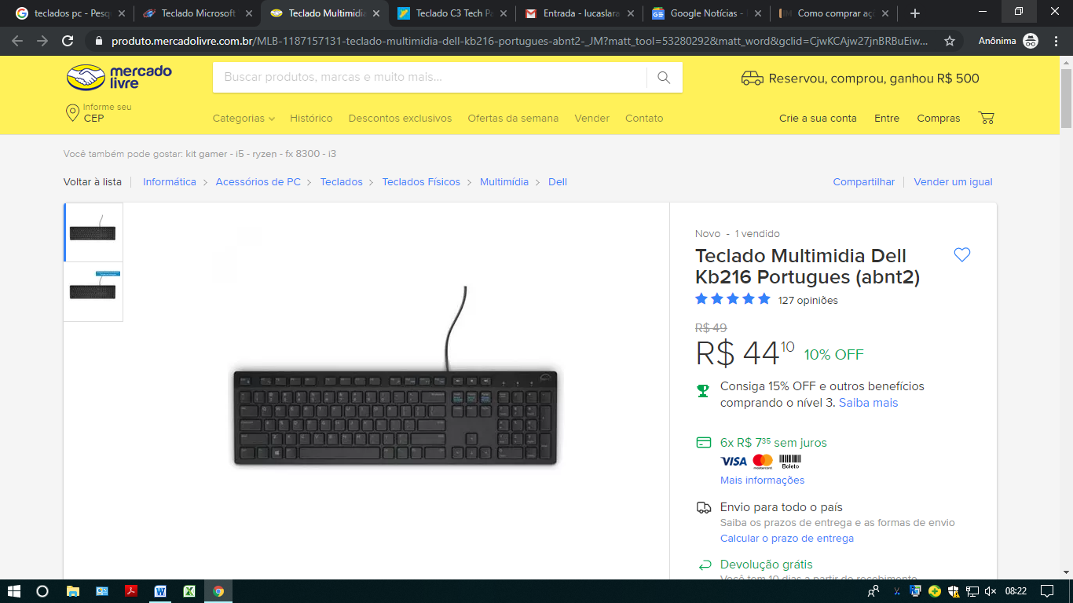
https://produto.mercadolivre.com.br/MLB-1187157131-teclado-multimidia-dell-kb216-portugues-abnt2-_JM?matt_tool=53280292&matt_word&gclid=CjwKCAjw27jnBRBuEiwAdjQXDO_9XiUTHmwBlp-bhRqSVkzfIzEnOcfxBHexEq90CxZec58GbTTxYxoCZ_MQAvD_BwE&quantity=1&variation=33559469976
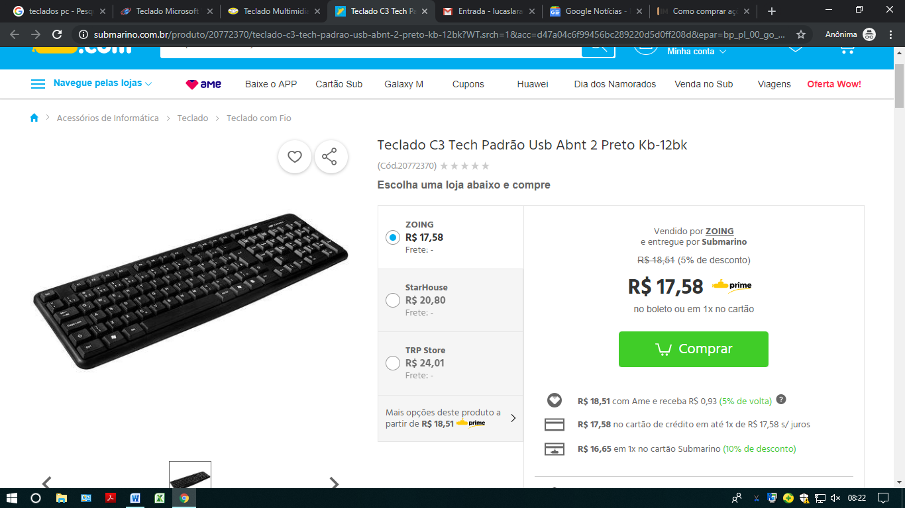
https://www.submarino.com.br/produto/20772370/teclado-c3-tech-padrao-usb-abnt-2-preto-kb-12bk?WT.srch=1&acc=d47a04c6f99456bc289220d5d0ff208d&epar=bp_pl_00_go_g35172&gclid=CjwKCAjw27jnBRBuEiwAdjQXDM1Fm6Fzjzv_e7e4NFai884nNbFOwC8e9Q0mT2Ow1daFRBCflbKU-xoCyuAQAvD_BwE&i=59816320eec3dfb1f85fc3bd&o=58f675eeeec3dfb1f8a70118&opn=XMLGOOGLE&sellerId=9146661000102

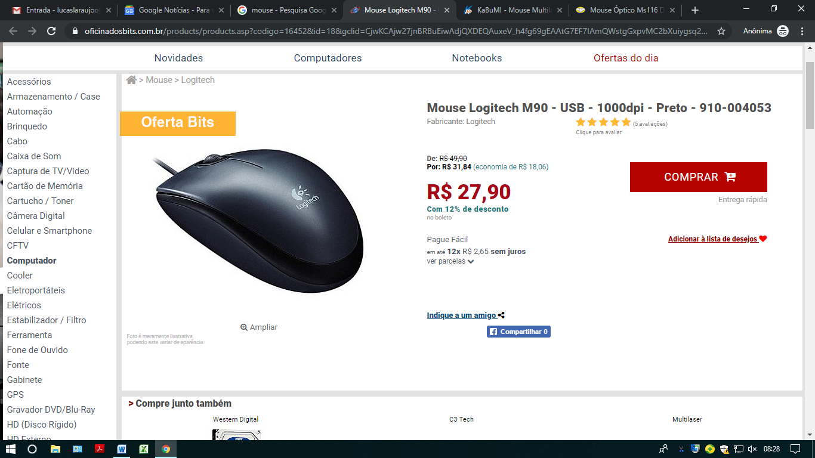
https://www.oficinadosbits.com.br/products/products.asp?codigo=16452&id=18&gclid=CjwKCAjw27jnBRBuEiwAdjQXDEQAuxeV_h4fg69gEAAtG7EF7IAmQWstgGxpvMC2bXuiygsq2vQfvxoC4lIQAvD_BwE
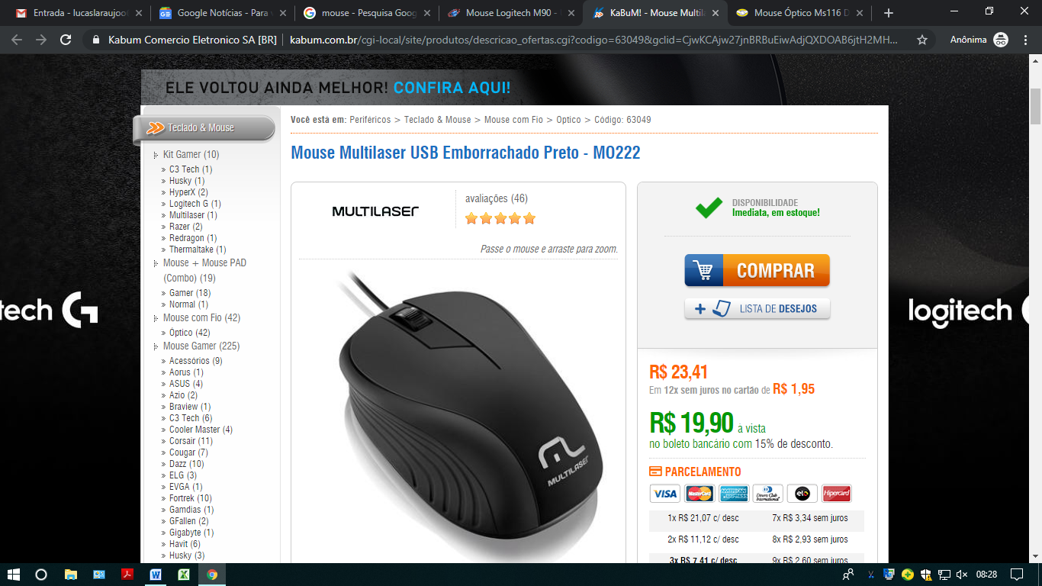
https://www.kabum.com.br/cgi-local/site/produtos/descricao_ofertas.cgi?codigo=63049&gclid=CjwKCAjw27jnBRBuEiwAdjQXDOAB6jtH2MHNXQ0upXxcUISs6pPuu8uJVXiHYe3NIRSbxw4oLbWvlhoCn0kQAvD_BwE
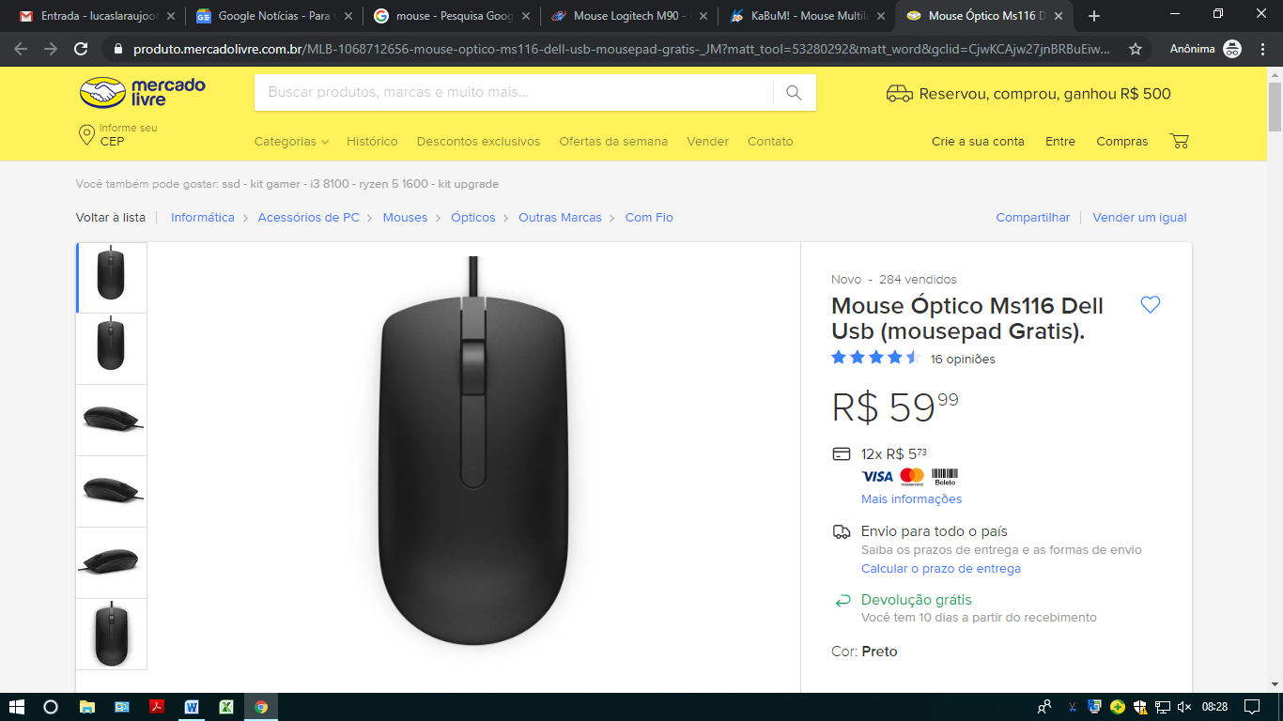
https://produto.mercadolivre.com.br/MLB-1068712656-mouse-optico-ms116-dell-usb-mousepad-gratis-_JM?matt_tool=53280292&matt_word&gclid=CjwKCAjw27jnBRBuEiwAdjQXDM5TPxhphm8zW4OTYorB-B59ECibG5rabBmPW9y4k52NhnIg-udOXRoCf9IQAvD_BwE&quantity=1&variation=32805573598

PACOTE MICROSOFT OFFICE BUSINESS
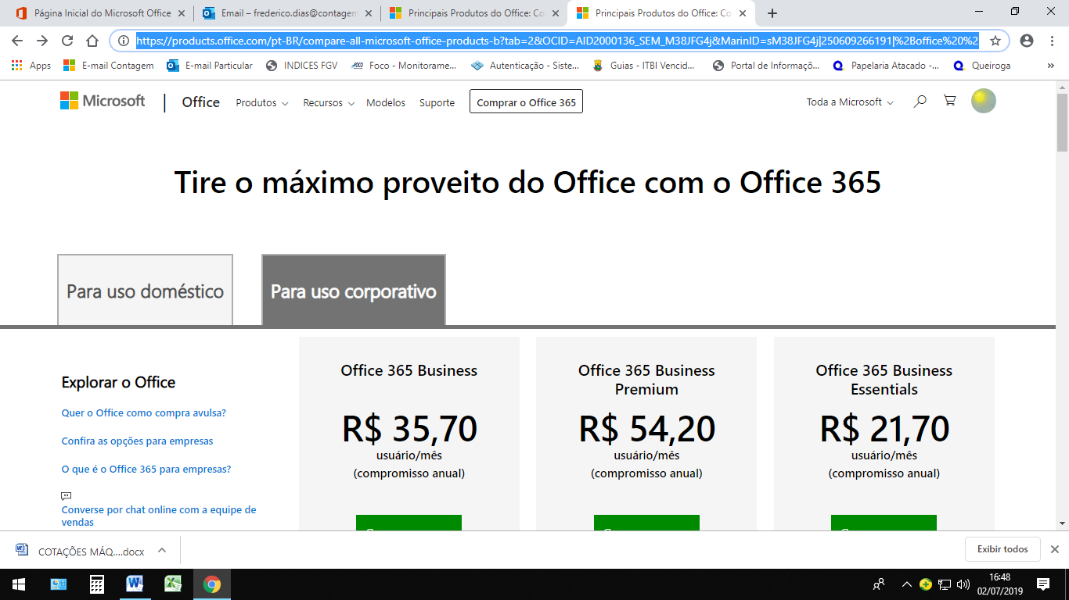

https://products.office.com/pt-BR/compare-all-microsoft-office-products-b?tab=2&OCID=AID2000136_SEM_M38JFG4j&MarinID=sM38JFG4j|250609266191|%2Boffice%20%2Bbusiness|b|c||54465832551|aud-312771921029:kwd-304532550411&lnkd=Google_O365SMB_Brand&gclid=EAIaIQobChMIurTpo_-W4wIVTYCRCh202wpDEAAYASAAEgLQDPD_BwE
ANTIVIRUS

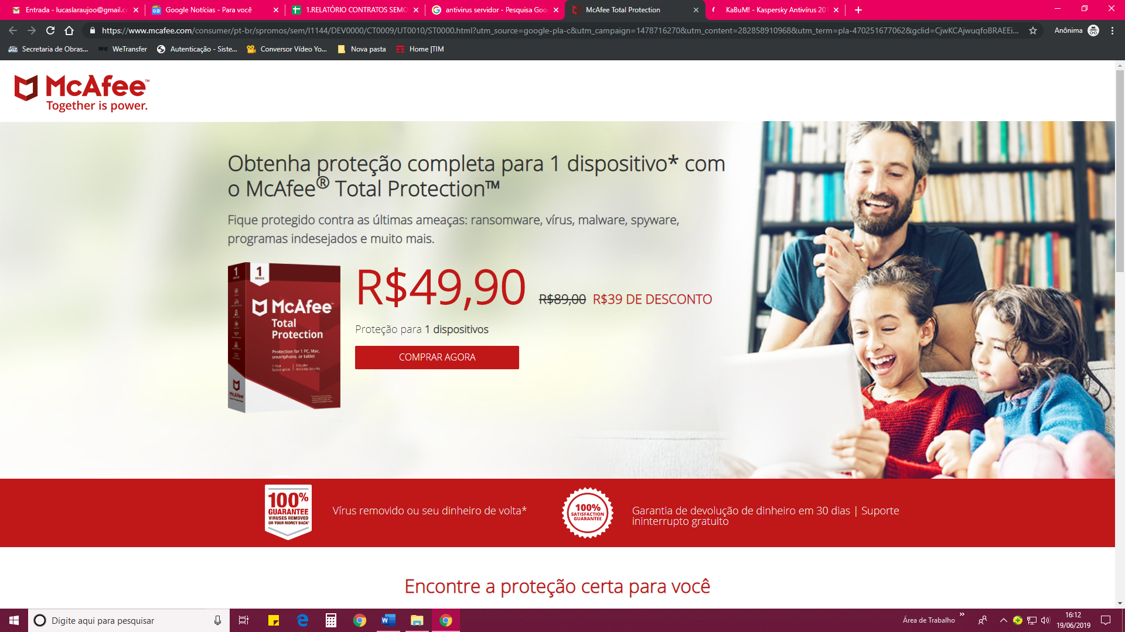
MCAFEE Antivírus
Valor R$49,90
https://www.mcafee.com/consumer/pt-br/spromos/sem/l1144/DEV0000/CT0009/UT0010/ST0000.html?utm_source=google-pla-c&utm_campaign=1478716270&utm_content=282858910968&utm_term=pla-470251677062&gclid=CjwKCAjwuqfoBRAEEiwAZErCspR4pZK0Z14Lh9z1oJTWCw3lvp05efoJ6iqgvYe3SbEFM8pKFIogFxoCyckQAvD_BwE

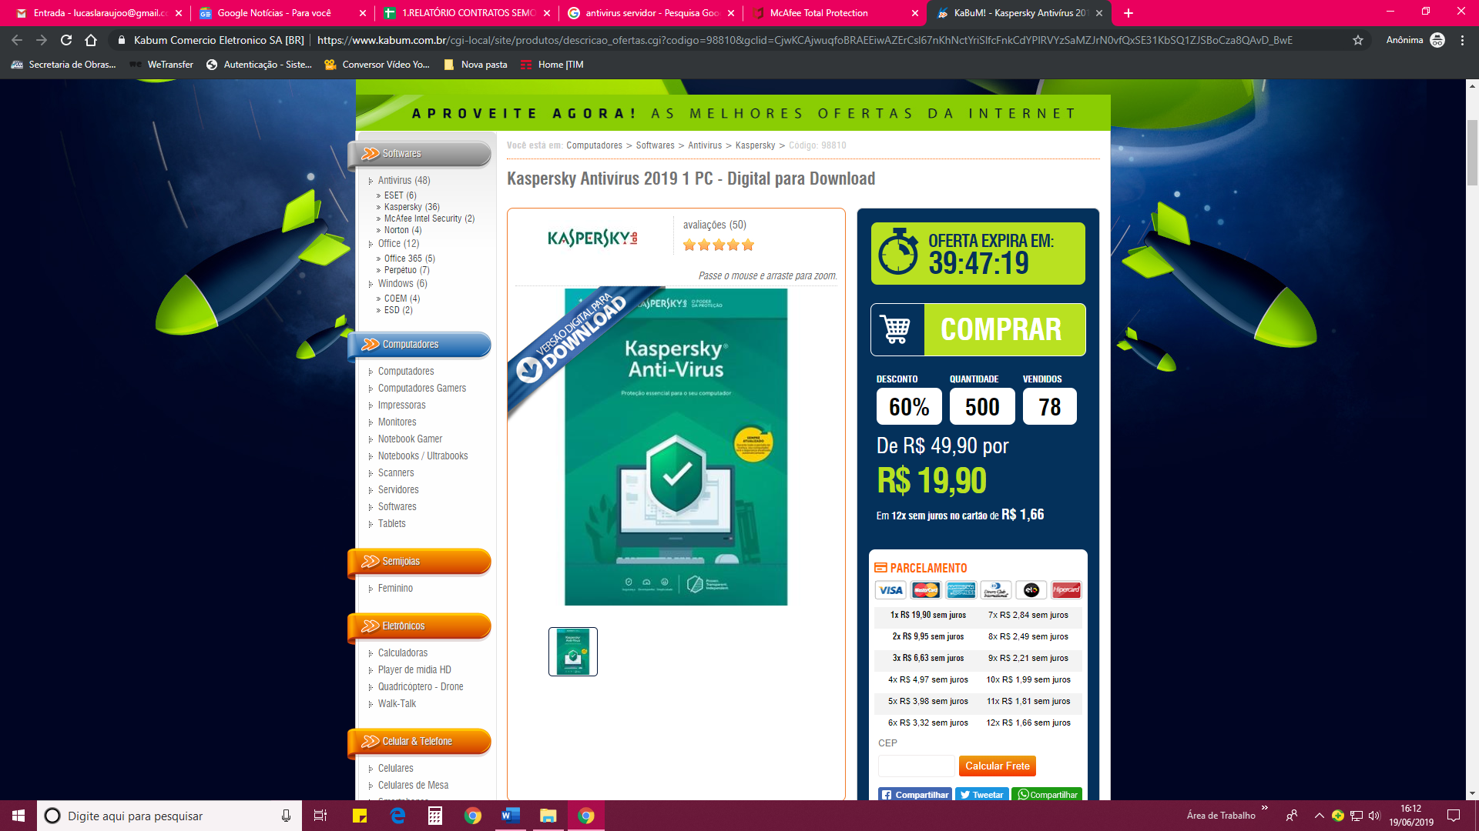
KARPERSKY Antivírus
Valor R$19,90
https://www.kabum.com.br/cgi-local/site/produtos/descricao_ofertas.cgi?codigo=98810&gclid=CjwKCAjwuqfoBRAEEiwAZErCsl67nKhNctYriSlfcFnkCdYPlRVYzSaMZJrN0vfQxSE31KbSQ1ZJSBoCza8QAvD_BwE

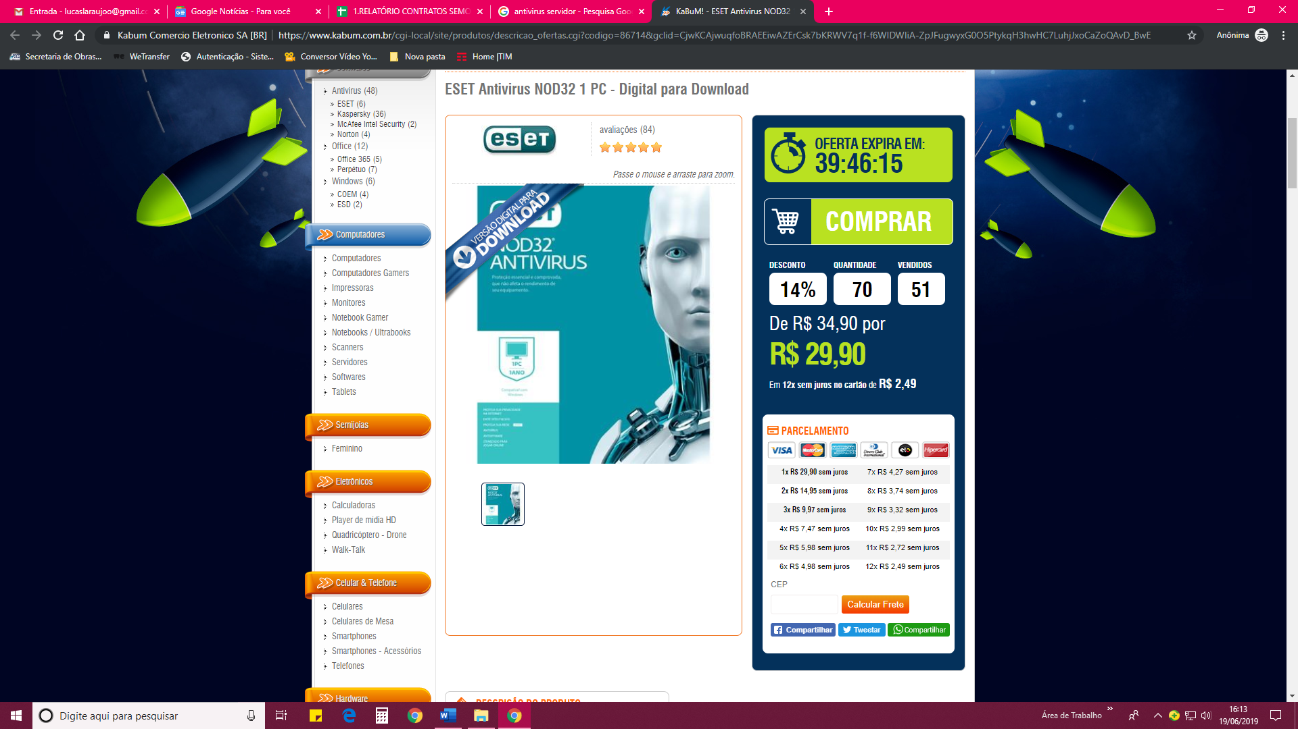
NOD32 Antivírus
Valor R$29,90
https://www.kabum.com.br/cgi-local/site/produtos/descricao_ofertas.cgi?codigo=86714&gclid=CjwKCAjwuqfoBRAEEiwAZErCsk7bKRWV7q1f-f6WIDWIiA-ZpJFugwyxG0O5PtykqH3hwHC7LuhjJxoCaZoQAvD_BwE

ESTABILIZADOR

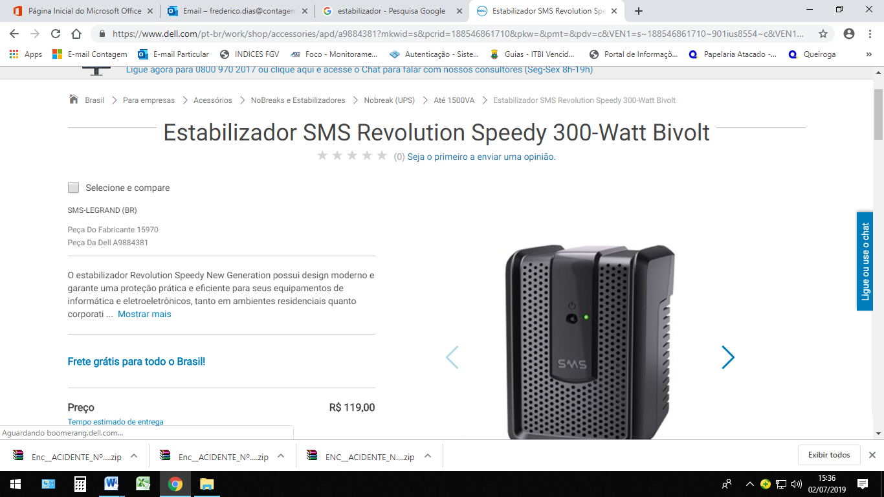

Estabilizador DELL
R$ 119,00
https://www.dell.com/pt-br/work/shop/accessories/apd/a9884381?mkwid=s&pcrid=188546861710&pkw=&pmt=&pdv=c&VEN1=s~188546861710~901ius8554~c&VEN1=s~188546861710~901ius8554~c&VEN2=~&VEN2=~&cid=310575&lid=5861039&dgc=st&dgc=st&dgseg=bsd&dgseg=bsd&acd=12255132728347400&acd=12255132728347400&st=&gclid=EAIaIQobChMI5tyyi-2W4wIVDQ2RCh0CyAWSEAQYASABEgKbpfD_BwE&VEN3=112004761222515696

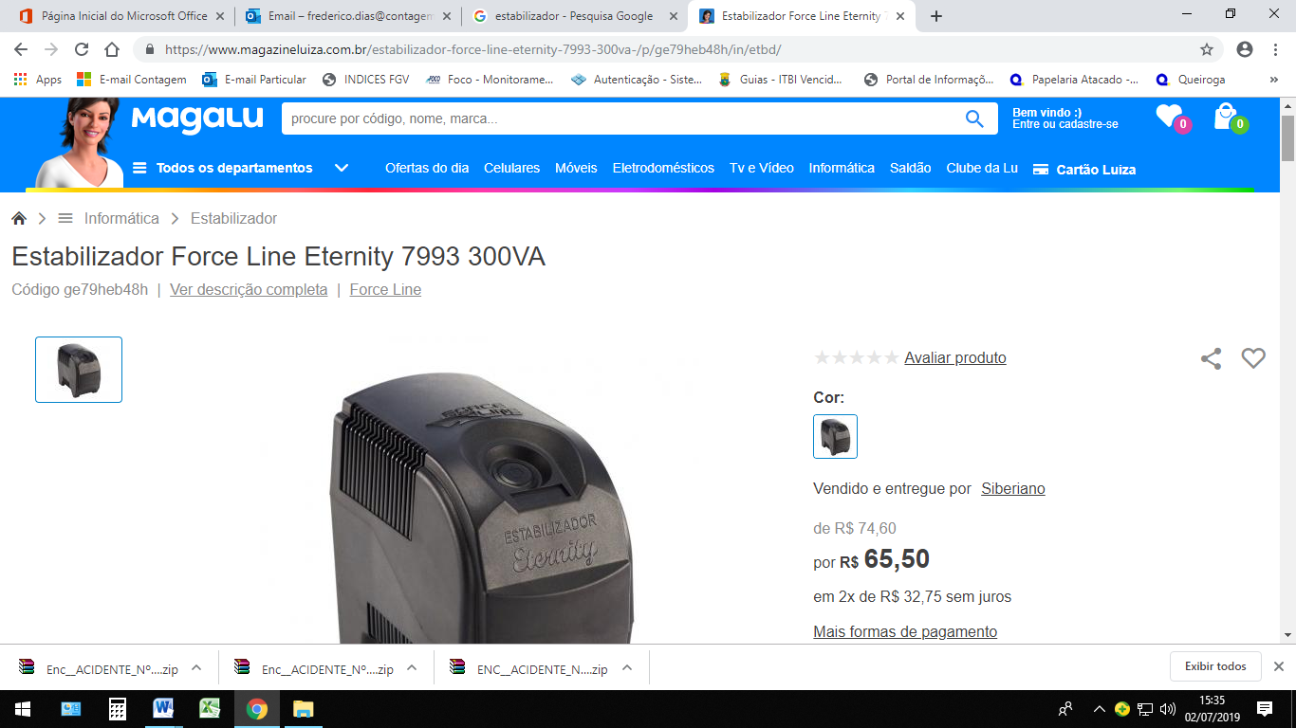

Estabilizador Eternity
R$65,50
https://www.magazineluiza.com.br/estabilizador-force-line-eternity-7993-300va-/p/ge79heb48h/in/etbd/

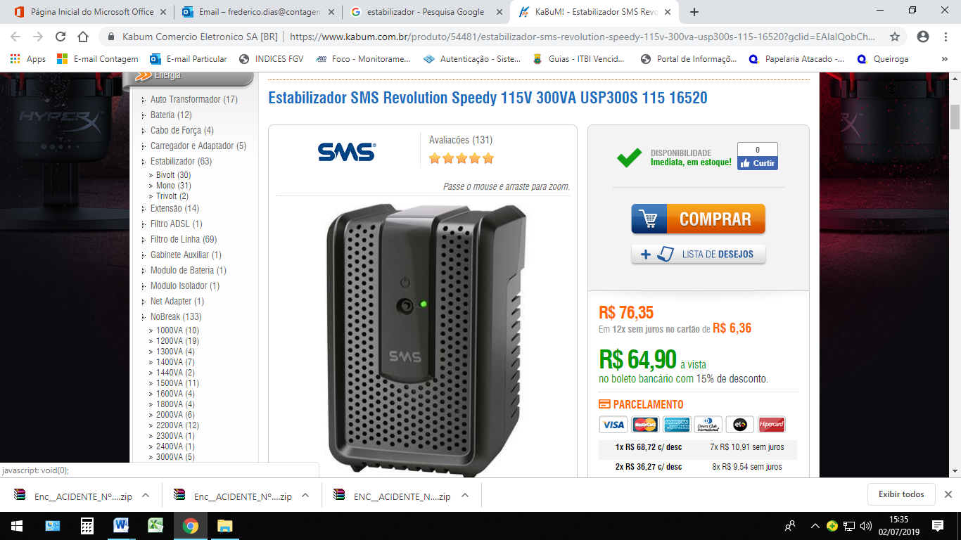

Estabilizador SMS
R$64,90
https://www.kabum.com.br/produto/54481/estabilizador-sms-revolution-speedy-115v-300va-usp300s-115-16520?gclid=EAIaIQobChMI8cXt0--W4wIViAqRCh3mZgNhEAkYAiABEgLHBPD_BwE

FILTRO DE LINHA
